Mount Wachusett Community College

Advanced Manufacturing Industrial Readiness Training

Success Skills Workbook

This project is sponsored by a $15.9 million grant from the U.S. Department of Labor, Employment and Training Administration.
The AMMQC program is an Equal Opportunity program. Adaptive equipment is available upon request for individuals with disabilities. This workforce product was funded by a grant awarded by the U.S. Department of Labor’s Employment and Training Administration. The product was created by the grantee and does not necessarily reflect the official position of the U.S. Department of Labor. The U.S. Department of Labor makes no guarantees, warranties, or assurances of any kind, express or implied, with respect to such information, including any information on linked sites and including, but not limited to, accuracy of the information or its completeness, timeliness, usefulness, adequacy, continued availability, or ownership.
http://creativecommons.org/licenses/by/3.0 This work is licensed under a Creative Commons Attribution 3.0 Unported License [http://creativecommons.org/licenses/by/3.0]

Table of Contents

Goal Setting 2
Team Building 10
Time Management 12
Stress Management 16
Communication 22
Critical Thinking 28
Workplace Culture 30
Job Search 39
Resume and Cover Letter 42
Interviewing 46

Goal Setting

Thinking about Goals

Why do/don’t you set goals for yourself?

What are some goals you have set for yourself?

How often do you review your goals?

How do you reward yourself for meeting your goals?

Creating Your Personal Vision Statement

Step One: Identify Your Values
The list below reflects some common values. Choose the ten that are most important to you as a person (meaning that they apply both at work and at home). You can customize the wording, or add your own to the list.

Ability to make decisions and implement them | Ability to persuade and influence others | Achieving excellence
Achieving fame and recognition | Adventure and excitement | Behaving ethically
Being challenged by pressures and deadlines | Being organized and dependable | Being skilled and capable
Building a family | Building meaningful relationships with others | Competition with others
Contributing to society | Cooperation with others | Demonstrating expertise
Diversity in daily tasks | Doing something meaningful | Efficient and effective
Enjoying what you do | Environmental rights | Establishing a reputation
Expressing creativity | Feeling excited and stimulated by life | Feeling independent
Feeling of belonging and community | Feeling of inner harmony | Feeling of patriotism
Financial security | Financial wealth | Free speech/human rights
Freedom to set your own pace and goals | Having a feeling of security | Having power and control
Having privacy | Helping those in need | Religion and/or spirituality
Leading others to success | Moving at a fast pace | Moving at a slow pace
Being productive | Reliability | Self-development
Sense of accomplishment | Serving the public | Spontaneity
Truth and integrity | Working as part of a team | Working individually

Creating Your Personal Vision Statement

We cannot focus on too many things at one time and remain effective. Look at the ten values you selected and select the five that are most important to you. Cross the others off. Be firm with yourself if you need to be. Remember, you are focusing on what is really important to you.

Next, reduce the list to just three values. These are the things at your very core. Cross the other two off your list. Put circles around the three items that are your core values.
Step Two: Define Your Values
Now, outline what success for each of those values would look like.

Value One

Value Two

Value Three

Creating Your Personal Vision Statement
Step Three: Put It All Together
Finally, bring the three statements together into one paragraph. You may feel that you need to go back and re-evaluate your values, or you may want to re-work some sentences to create what is meaningful to you. That’s OK! Above all, this should be a reflection of your innermost thoughts and a roadmap for how you would like to conduct your life.

Write your personal vision statement here.

Reflecting on Your Personal Vision Statement

How do you live your life according to your core values?

How are your goals are based on your values?

How do your friends and co-workers share similar values?

How do your family and friends know what your values are?

Your Personal Vision Statement as the Foundation

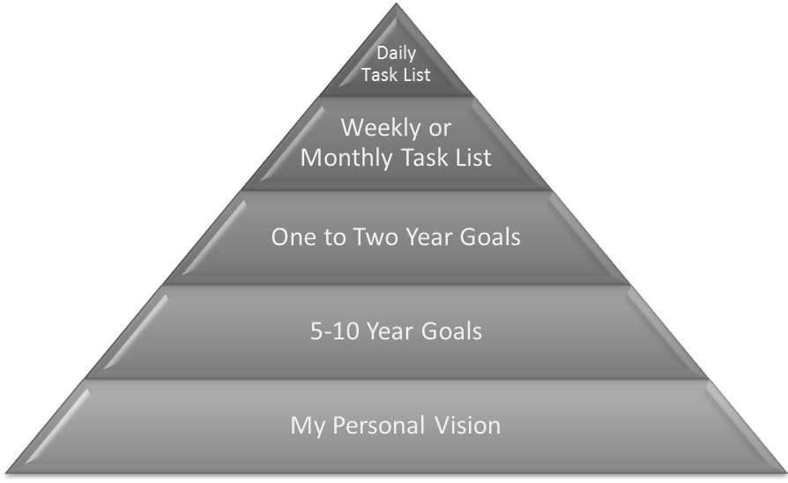

Writing about Goals

What areas of your life do you want to set goals in?

Do these reflect your vision statement and values? How or how not?

Do your goals really reflect who you are?

Smart Goal Worksheet
Today’s Date: __________________ Goal Completion Deadline: _________________
My Goal is: __________________________________________________________________________________________________________________________________________________________________________________________________________________________________________
Answer the questions below to help develop and clearly define your goal
S | SPECIFIC:  What exactly am I going to do?  What do I want to accomplish?
M | MEASURABLE:  How will I know when I have reached my goal?
A | ACHIEVABLE /ATTAINABLE:  Is the goal too easy or too difficult to reach?  Is achieving this goal realistic with effort and commitment?  Do I have the resources to achieve this goal?
R | RELEVANT:  Why is this goal significant to my life?  What are some potential challenges I will have to overcome?
T | TIMELY:  When will I achieve this goal?  What is my anticipated date of completion?  Are there official deadlines to this goal?

Team Building

Have you ever been on a successful team?
_______________________________________________________________________________________________________________________________________________________________________________________________________________________________________________________________

What made that team successful?
_______________________________________________________________________________________________________________________________________________________________________________________________________________________________________________________________

What are some other characteristics of a successful team?
_______________________________________________________________________________________________________________________________________________________________________________________________________________________________________________________________

Have you ever been on an unsuccessful team?
_______________________________________________________________________________________________________________________________________________________________________________________________________________________________________________________________

What made that team unsuccessful?
_______________________________________________________________________________________________________________________________________________________________________________________________________________________________________________________________

What are some other characteristics of an unsuccessful team?
_______________________________________________________________________________________________________________________________________________________________________________________________________________________________________________________________

Stranded on a Mountain

After your small light aircraft crashes, your group, wearing casual clothing, is stranded on a forested mountain in winter weather (snow covered, sub-freezing conditions), anywhere between 50 and 200 miles from civilization (you are not sure of your whereabouts, and radio contact was lost one hour before you crashed, so the search operation has no precise idea of your location either). The plane is about to burst into flames and you have a few moments to gather some items. Aside from the clothes you are wearing, which does not include coats, you have no other items. It is possible that you may be within cell phone signal range, but unlikely.

Your aim is to survive as a group until rescued. From the following list choose just ten items that you would take from the plane, after which it and everything inside is destroyed by fire.

Choose 10 Items:
- Pack of 6 boxes x 50 matches
- Roll of polythene sheeting 3m x 2m
- 1 bottle of brandy
- 1 crate of bottled spring water (six gallons)
- Small toolbox containing hammer, screwdriver set, adjustable wrench, hacksaw, large pen-knife
- Box of distress signal flares
- Small basic first-aid kit containing plasters, bandages, antiseptic ointment, small pair of scissors and pain-killer tablets
- Cell phone with battery half-charged
- Clockwork transistor radio
- Gallon container full of fresh water
- Box of 36 chocolate bars
- Shovel
- Short hand-held axe
- Box of 24 bags of peanuts
- Box of tissues
- Laptop computer with unknown software and data and unknown battery life
- Inflatable 4-person life-raft
- Compass
- Large full Aerosol can of insect killer spray
- Small half-full aerosol can of air freshener spray
- Notebook and pencil
- Travel games kit containing chess, backgammon, & checkers
- Sewing kit
- Whistle
- Flashlight with a set of spare batteries
- Box of 50 6hr candles
- Bag of 6 large blankets
- Hand-gun with magazine of 20 rounds
- 20ft of nylon rope
Time Management

Writing About Time

What are your top three priorities?

What are the top three obstacles to working on your priorities or meeting your objectives?

On a scale of one to ten, how would you rate your organizational skills right now? Why?

How would you spend any additional time if you found a way to give it to yourself?

Time Management Self-Assessment

Take the following self-assessment by circling R for rarely, S for sometimes, and O for often.

1. Do you prioritize your "To Do" list? Rarely Sometimes Often
2. Do you complete tasks at the last minute? R S O
3. Do you set aside time for planning and scheduling? R S O
4. Do you know how much time you spend on tasks? R S O
5. Do you use goal setting to decide what tasks and activities you should work on? R S O
6. Do you leave extra time in your schedule for unexpected circumstances? R S O
7. Do you know if the tasks you are working on are high, medium, or low value? R S O

8. Do you analyze new tasks for importance and prioritize them accordingly? R S O
9. Are you stressed about deadlines and commitments? R S O
10. Do distractions keep you from working on important tasks? R S O

Scoring:

For questions 1, 3, 4, 5, 6, 7, and 8: 1 point for every R, 2 points for each S, and 3 points for an O.
For questions 2, 9, and 10: 3 points for each R, 2 points for an S, and 1 point for every O.

Score:

24-30: Congratulations, you manage your time effectively! But even if you scored all 30 points, you can
still learn some great tips for strengthening your abilities and maximizing your efforts.

17-23: You are skilled in certain aspects of time management, but are not as strong in others.
There is always room for improvement, though, and this workshop will show you how.

10-16: Time management is not one of your strengths. However, the good news is that time
management is a skill that can be learned and improved upon. Making changes and
incorporating some of the tips covered in this workshop will be important to improving your effectiveness and success at work and home.
Case Study

Another Day at the Office

It was 7:20 a.m. when Myron arrived at the office. He was early because he wanted to clear the backlog of work that had been piling up on his desk. He turned on the lights and started to go through yesterday's mail. As he read the first piece, he realized he couldn't deal with it until a colleague arrived. He set it aside and went to the next. This item had potential application to a project he was working on, so he walked down the hall and made a copy for his personal use.

As he continued reading his mail, he came across a journal article of particular interest and become engrossed in it. As he looked up, he was startled to find that others were arriving and it was nearly 9:00.

He quickly pushed the remaining mail to a corner of his desk and reached for a project file due tomorrow with at least two days of work yet to be completed. As he opened the file, Bill and Claire stopped by and invited him to join them for coffee. Myron decided he could spare ten minutes. Bill and Claire were both anxious to share the details of a play they attended last night. Before Myron realized it, thirty minutes had passed and he hurried back to his office.

As Myron entered his office, the phone rang. It was Mr. Wilson, his manager. There was a meeting scheduled at 10:00. Could Myron sit in for him? There was something to be discussed that the department should know about. Myron looked at his watch. There wasn't enough time to get started on the project so he pushed the file aside and vowed to start it immediately after lunch.

The afternoon wasn't any better. A few visitors, a few phone calls, a couple of letters, and the day was over. Nothing had been accomplished on the project that was due tomorrow. As he stuffed papers into his briefcase, he wondered how Bill and Claire were able to attend plays during the evening.

How Do You Spend Your Day?

Activities
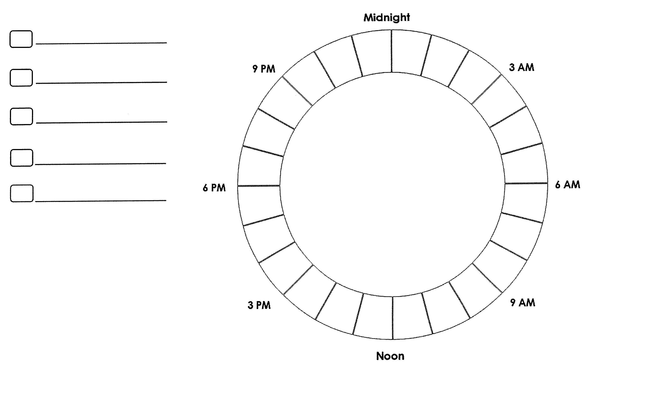

Stress Management

How Vulnerable are You to Stress?
Mark from a range of 1 (almost always) to 5 (never), according to how much of the time each statement applies to you.
Number | Behaviors that Help Manage Stress
 | I eat at least one hot, balanced meal a day.
 | I get 7-8 hours of sleep at least 4 nights per week.
 | I give and receive affection regularly.
 | I have at least one family member within 50 miles on whom I can rely.
 | I exercise to the point of breaking a sweat at least twice per week.
 | I smoke less than a half a pack of cigarettes a day.
 | I take fewer than 5 alcoholic drinks a week.
 | My weight is appropriate for my height.
 | I have an income that meets my basic expenses.
 | I get strength from my spiritual beliefs.
 | I regularly attend club or social activities.
 | I have a network of good friends and acquaintances.
 | I have one or more friends to confide in about personal matters.
 | I am in good health.
 | I am able to speak openly about my feelings when angry or worried.
 | I do something fun at least one time per week.
 | I am able to talk with the people I live with about domestic issues.
 | I am able to organize my time effectively.
 | I take quiet/relaxation time for myself during the day.
 | I drink fewer than 3 cups of caffeinated drinks per day.
Subtotal _______ - 20 = _______ Total
Add your score. Then, subtract 20. Any number over 5 indicates a vulnerability to stress. Scores between 25-55 indicate that you are seriously vulnerable to stress. If your score is over 55 you may be extremely vulnerable to stress.

Food Journal

Date:
 | Dairy | Fruit | Grains | Protein | Veggies | Other
Totals

Workplace Stretching

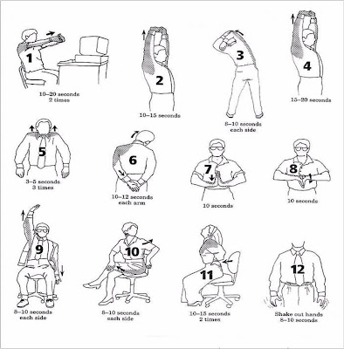

Tips to Relieve Stress

When you feel stressed, you can:
- Take slow, deep breaths
- Soak in a warm bath
- Listen to soothing music
- Take a walk or do some other activity
- Meditate or pray
- Take a yoga class
- Have a massage or back rub
- Have a warm drink that doesn't have alcohol or caffeine

You also can make some changes in your everyday habits to reduce and relieve stress.
- Get plenty of sleep
- Stay connected to your family, friends, and other caring people in your life
- Get regular exercise. It can help you clear your mind and work off feelings of frustration and anxiety
- Don't drink or eat anything that has caffeine in it. Caffeine can make you feel "wound up" and more stressed
- Don't smoke or use tobacco: nicotine can make you feel more anxious.
- Don't drink alcohol: it can cause sleep problems and depression.

Muscle Relaxation to Relieve Stress

Your body may respond to stress by tensing up, which can cause pain. If you learn to relax your muscles, you can reduce muscle tension and anxiety. Progressive muscle relaxation is an exercise that can help you do this.

In progressive muscle relaxation, you tense and then relax related groups of muscles. You can use a relaxation tape or CD to help you go through all the muscle groups. Or you can learn the muscle groups and work through them from memory.

Find a quiet place where you won't be bothered. Be sure you can lie on your back in comfort.

For each muscle group:
- Breathe in and tense the muscle group for 4 to 10 seconds. Tense hard, but not to the point of cramping.
- Then breathe out while you suddenly and completely relax the muscle group. Don't relax it gradually.
- Rest for 10 to 20 seconds.

Here are the muscle groups:
- Hands and arms
  - Hands: Make a tight fist.
  - Wrists and forearms: Tense them and bend your hands back at the wrist.
  - Biceps and upper arms: Make your hands into fists, bend your arms at the elbows, and tense your biceps.
  - Shoulders: Shrug them.

- Head and neck
  - Forehead: Wrinkle it into a deep frown.
  - Around the eyes and bridge of the nose: Close your eyes as tightly as possible. If you wear contact lenses, remove them before beginning the exercise.
  - Cheeks and jaws: Smile as widely as you can.
  - Around the mouth: Press your lips together tightly.
  - Back of the neck: Press your head back against the floor or chair.
  - Front of the neck: Touch your chin to your chest.

- Upper body
  - Chest: Take a deep breath and hold it, then breathe out.
  - Back: Arch your back up and away from the floor or chair.
  - Stomach: Suck it into a tight knot.

- Lower body
  - Hips and rear end (buttocks): Press the buttocks together tightly.
  - Thighs: Clench them hard.
  - Lower legs: Push your heels out and flex your toes up, as if trying to bring the toes up to touch your shins. Then point your toes away and curl them downward.

You may feel sleepy after doing this exercise. To "wake up" your body, count backwards from 5 to 1. Then move your fingers, toes, hands, and feet. Finally, stretch and move your entire body. Be sure you are alert before you drive or do other activities.

Roll Breathing to Relieve Stress

Roll breathing helps you use your lungs better and gets you in touch with the rhythm of your breathing. You can practice it in any position, but it's best to lie on your back, with your knees bent. Practice roll breathing daily for several weeks until you can do it almost anywhere.

When you are roll breathing, always breathe in through your nose and breathe out through your mouth. As you breathe out, make a whooshing sound.
- Place your left hand on your belly and your right hand on your chest. Notice how your hands move as you breathe in and out.
- Breathe in to fill your lower lungs. Your belly will push your left hand up as you do this. Your right hand won't move. Then breathe out. Your left hand will fall as your belly falls. Do this 8 to 10 times.
- Next, breathe in as you did before, but don't stop after your left hand pushes up. Continue to breathe in. You will feel your upper chest expand and push your right hand up. Your left hand will fall a little as your belly falls.
- Breathe out slowly through your mouth. As you breathe out, feel the tension leaving your body. Both your hands will fall.
- Do this for 3 to 5 minutes. Notice how your belly and chest move like waves, rising and falling in a steady motion.
- Notice how you feel after you breathe this way.

Caution: Some people get dizzy the first few times they try roll breathing. If you begin to breathe very fast or become lightheaded, slow your breathing. Get up slowly.

In addition to meditation, progressive muscle relaxation, and breathing exercises to relieve stress, you might try these other therapies.

Ways to relax your mind
- Self-hypnosis can open your mind to suggestions that can relieve stress or change the way you respond to stress.
- Autogenic training includes six exercises that make the body relax. Each exercise helps you relax your body in a different way.
- Music therapy can relax your body, improve your mood, and change the pace of your day.
- Humor therapy may reduce stress and boost your immune system.

Ways to relax your body
- Massage, such as a shoulder and neck massage, uses touch to relieve tension. You can see a massage therapist or have a friend or family member give you a massage. You can even give yourself a massage.
- Aromatherapy uses the aroma-producing oils from plants to help you relax.
- Biofeedback teaches you how to use your mind to control skin temperature, muscle tension, heart rate, or blood pressure. All of these things can be affected by stress.

Herbal supplements
- Some people use herbal supplements such as valerian, kava, gingko, St. John's Wort, and chamomile to relieve stress symptoms such as anxiety and insomnia. Supplements like these can be sold with limited or no research on how well they work and can affect other medications that you may be taking. Talk with your doctor if you are taking supplements, especially if you have another health condition.

Communication

Communication Survey
- I try to anticipate and predict possible causes of confusion, and I deal with them up front.
- When I write a memo, email, or other document, I give all of the background information and detail I can to make sure that my message is understood.
- If I don't understand something, I tend to keep this to myself and figure it out later.
- I'm sometimes surprised to find that people haven't understood what I've said.
- I can tend to say what I think, without worrying about how the other person perceives it. I assume that we'll be able to work it out later.
- When people talk to me, I try to see their perspectives.
- I use email to communicate complex issues with people. It's quick and efficient.
- When I finish writing a report, memo, or email, I scan it quickly for typos and so forth, and then send it off right away.
- When talking to people, I pay attention to their body language.
- I use diagrams and charts to help express my ideas.
- Before I communicate, I think about what the person needs to know, and how best to convey it.
- When someone's talking to me, I think about what I'm going to say next to make sure I get my point across correctly.
- Before I send a message, I think about the best way to communicate it (in person, over the phone, in a newsletter, via memo, and so on).
- I try to help people understand the underlying concepts behind the point I am discussing. This reduces misconceptions and increases understanding.
- I consider cultural barriers when planning my communications.

Always Sometimes Rarely/Never
- _____ ______ ______
- _____ ______ ______
- _____ ______ ______
- _____ ______ ______
- _____ ______ ______
- _____ ______ ______
- _____ ______ ______
- _____ ______ ______
- _____ ______ ______
- _____ ______ ______
- _____ ______ ______
- _____ ______ ______
- _____ ______ ______
- _____ ______ ______
- _____ ______ ______
Scoring:
5 points for each Always answer: _______
3 points for each Sometimes answer: _______
0 points for each Rarely/Never answer: _______
Total: ______

50-75 points: Excellent! You understand your role as a communicator, both when you send messages, and when you receive them. You anticipate problems, and you choose the right ways of communicating. People respect you for your ability to communicate clearly, and they appreciate your listening skills.

25-49 points: You're a capable communicator, but you sometimes experience communication problems. Take the time to think about your approach to communication, and focus on receiving messages effectively, as much as sending them. This will help you improve.

0-24 points: You need to keep working on your communication skills. You are not expressing yourself clearly, and you may not be receiving messages correctly either. The good news is that, by paying attention to communication, you can be much more effective at work, and enjoy much better working relationships! The rest of this article will direct you to some great tools for improving your communication skills.

Adapted from Mind Tools Communication Survey

Defining Communication

There are no right or wrong answers to these questions. Answer them according to your own opinion, then review with your classmates. When there are differences in opinion, let everyone explain and debate their position. Notice the various features and required conditions of communication assumed by different individuals.

Answer Yes or No

___ ___ 1. If you read and understand something written several centuries
ago, this is communication?

___ ___ 2. Can an inanimate object (clouds, an ocean, etc.) communicate to a person?

___ ___ 3. If you send a letter to someone who never receives it, but someone else
reads it and understands it, is this communication?

___ ___ 4. If you send a letter to someone who receives it, but misunderstands what
you meant by it, is this communication?

___ ___ 5. If you send a letter to someone, but it gets lost and no one ever reads it, is
this communication (not counting “communicating” with yourself when
writing the letter)?

___ ___ 6. Does a person have to be conscious of his or her goals in order for there to
be communication?

___ ___ 7. When a trained dog obeys a command, is this communication?

___ ___ 8. If you put your foot in front of an ordinary cockroach to “tell it” to change
direction, and it does, is this communication?

___ ___ 9. Can two nonhuman animals of the same species communicate with one
another?

___ ___ 10. Can a person communicate to an inanimate object such as a wall or cloud
or the ocean?

___ ___ 11. Is blushing a form of communication?

___ ___ 12. Is a spontaneous yawn a form of communication?

___ ___ 13. Is a fake yawn communication?

___ ___ 14. Could two people be talking and yet not be communicating?

___ ___ 15. Can a person communicate with himself or herself?

How Do You Rate Your Listening Ability?

One reason listening is so important is that we do so much of it every day. We know that good communicators spend far more of their time listening than they do talking. Like asking questions, listening is a skill that we can develop. In an age when we are inundated with media messages and portable devices, we can choose to be listening more than people did in the past.
Answer each of the following questions.

Question | Yes | No | Points
- Do you enjoy listening?
- Is it easy for you to listen with interest to a large variety of subjects?
- Do your friends seek you out to discuss a problem or decision when they need help?
- Does your attention usually stray toward other groups or people entering or leaving the room?
- Do you interrupt?
- Are you more apt to be thinking ahead to what you will say next rather than weighing what you are being told?
- Do you stop listening to everything when you strongly disagree with the speaker on one point?
- Do you assume or anticipate regarding the other person’s views?
- Do you feel you can judge most people quite quickly before hearing them out?
- Do you generalize (All old people think… all redheads… all college kids…)?
- Do you encourage others to elaborate or clarify points you have misunderstood?
- Do you listen to what is not said, such as the obvious omission?
GRAND TOTAL

Scoring
- Give yourself 2 points if you answered “Yes” for question 1. You enjoy listening as much as you enjoy talking.
- Give yourself 2 points if you answered “No” to questions 4, 5, 6, 7, 8, 9, and 10.
- Give yourself 2 points if you answered “Yes” to questions 2, 3, 11, and 12.
Interpretation
If your score is 20 or more, you've already developed some strong communication skills. You have the ability to listen to people, understand what they are saying, and communicate your understanding back to them. Use your listening and communication skills to help others.

If your score is between 10 and 18, you're within the average range. Use this quiz to help you identify where you’re doing well and where you would like to do better.

If your score is less than 10, it’s time to start learning! Use this quiz to help you set some goals. Start with one or two things that you would like to improve on, such as empathizing, paraphrasing, or asking good questions. Then, we’ll work on setting an action plan, and you’ll be on the road to being a better listener, and a better communicator.

What is Said vs. What is Heard

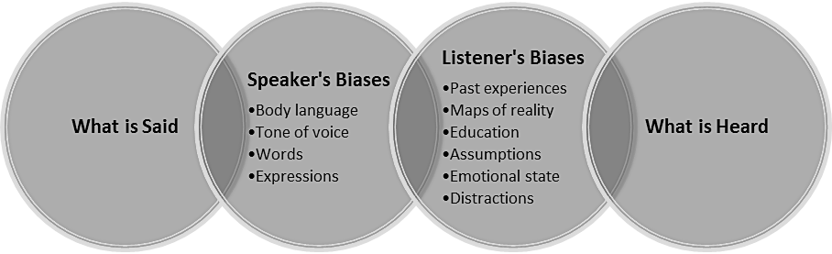

Communication Situations

What would you do if you were trying to talk to someone…

- In a noisy workplace?
________________________________________________________________________
________________________________________________________________________

- And there were lots of visual distractions around?
________________________________________________________________________
________________________________________________________________________

- And they had a very strong accent?
________________________________________________________________________
________________________________________________________________________

- And they were speaking too fast for you to understand?
________________________________________________________________________
________________________________________________________________________

- And they kept using jargon words or terms you didn’t understand?
________________________________________________________________________
________________________________________________________________________

- And they appeared to be very stressed?
________________________________________________________________________
________________________________________________________________________

Critical Thinking

Congratulations, you have just won 70 million dollars! Now you need to decide what to do with it all. Below you will find a proposal asking for funds. Use your critical thinking skills to evaluate the argument.

Proposal
Dear Lotto Recipient:

I saw that you recently came into a large fortune and would like to propose an endeavor that you might find worthwhile to support. My name is Dr. Annik Bailey. I am a veterinarian and have been with the Foundation for Endangered Animals for almost a year. I have primarily been working in Central Africa, where the bluefin whale is endangered. Many whales are killed each year, primarily due to incurable diseases. A whale disease research center would not only save this precious species, but it would also provide much-needed jobs for the uneducated population in the area.

Thank you for your consideration. I look forward to speaking with you soon.

Yours sincerely,

Annik Bailey

Critical Thinking Model

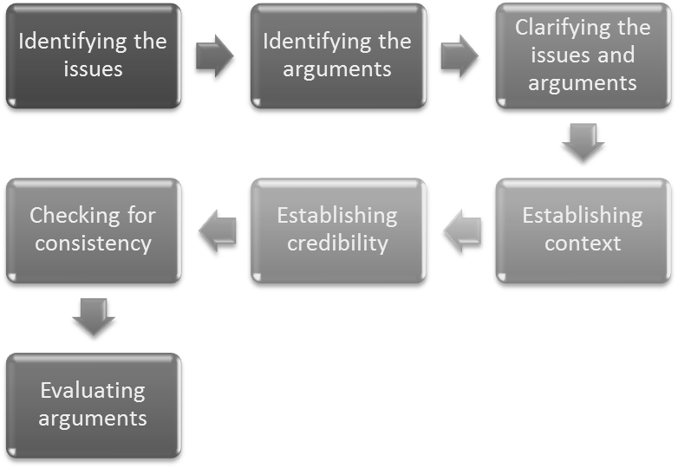

Workplace Culture

Find Someone Who . . .
Shares a favorite hobby
Parents or grandparents were born outside the United States
Speaks a language besides English
Enjoys the same sports
Has a disability they have had to overcome
Has children
Can build furniture
Loves taking pictures
Is a single parent
Was born in the same year as yourself
Attended your high school
Moved here from out of state
Has been in the military
Has participated on an athletic team
Can play a musical instrument or sing
Has played in a band
Knows how to take care of elderly people
Has chopped down a tree
Knows how to plant a vegetable garden
Has taught someone how to drive a car

Self-Awareness Inventory

Answer the questions using
1 for “never do/feel”
3 for “sometimes do/feel”
5 for “always do/feel”
Statement | My Rating
I try to look for similarities between people instead of differences.
I know that I have biases and I am aware of them.
I am interested in learning more about diversity and try to seek out information whenever I can.
I like being in new situations and trying new things.
I try to look for the positive aspects in situations and people.
I follow the platinum rule: treat others the way they want to be treated.
I try to be an effective communicator.
I try to practice empathy and put myself in other people’s shoes.
I know that diversity and discrimination can mean different things to different people.
I enjoy travelling to different places and experiencing new cultures.
TOTAL

Scoring:
10-24: Your attitude towards diversity would benefit from improvements. You may want to consider some changes and challenging yourself.
25-40: You have a pretty good attitude towards diversity, but could also benefit from implementing new strategies.
41-50: You have a great attitude towards diversity. Make sure to maintain your positive outlook.
Writing about Diversity

What am I currently doing to encourage diversity?

What changes could I make in my life to celebrate diversity more?

What is my next step to incorporate more diversity into my life?

Hazard Identification

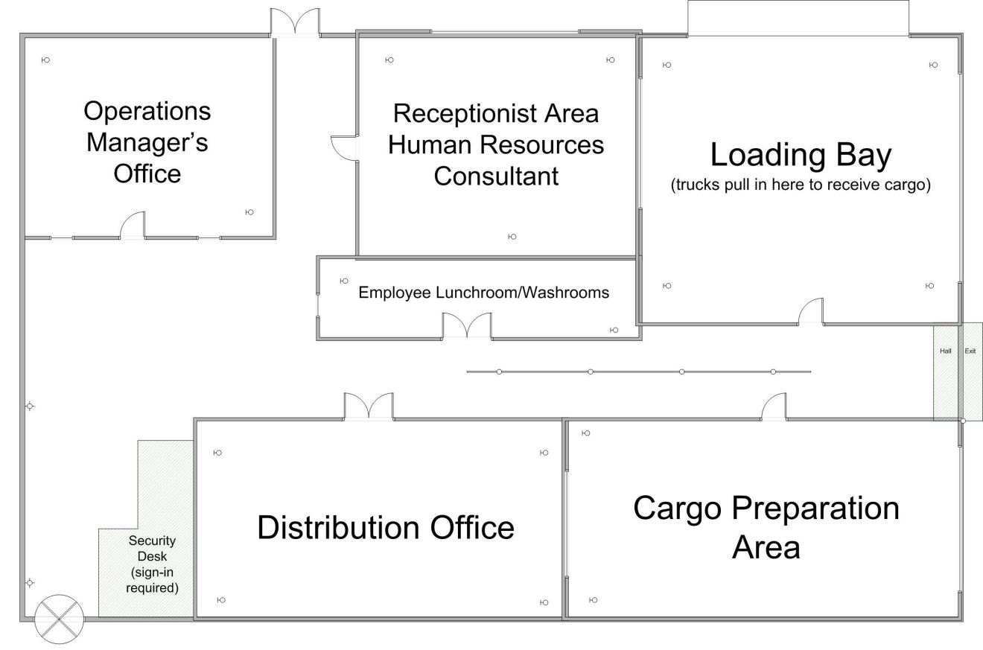

Resolving Hazards

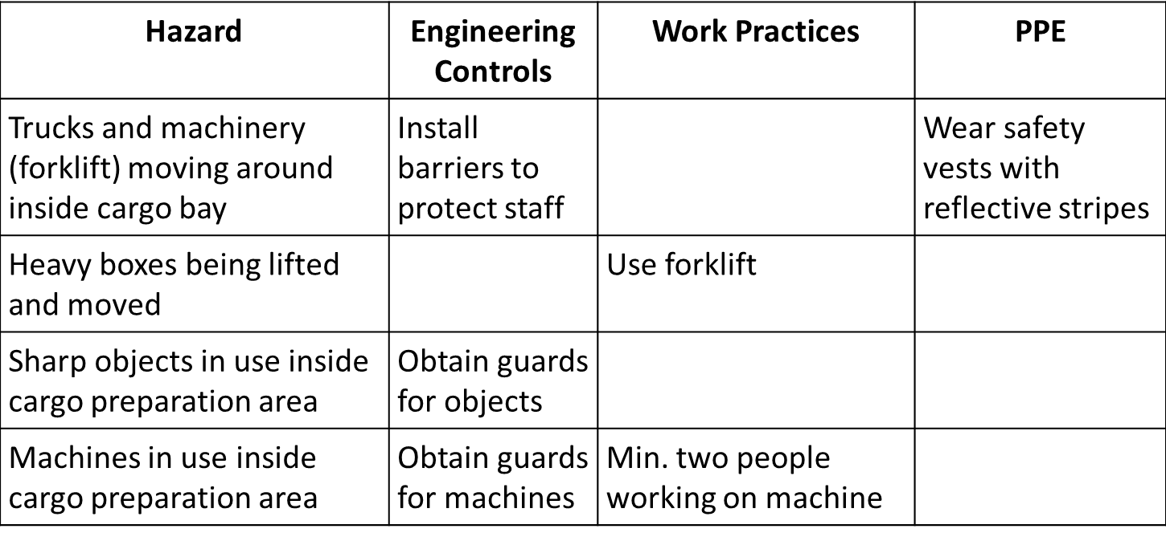

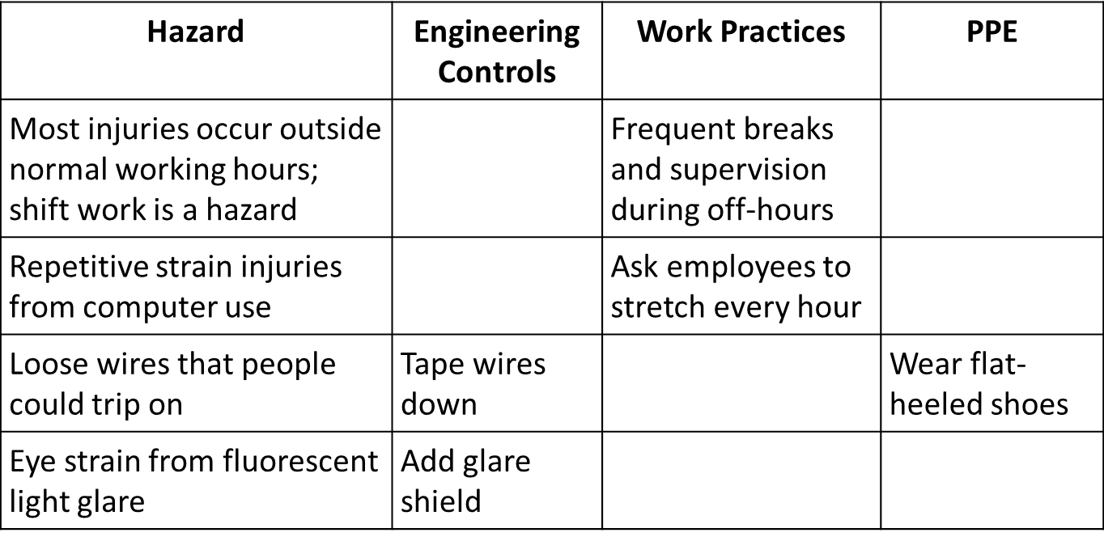

Incident Management

Inside a meat packing plant, 20 workers are all performing various tasks involving heavy machinery. Suddenly, a scream echoes through the factory. George, the foreman, has gotten his arm caught in one of the meat packing machines.

Panic erupts: one worker turns to stare and gets caught in the conveyor belt; another worker trips and falls as he tries to run from the scene; yet another worker falls into the vat that they have been cleaning out. No one has called for help and the scene is in complete chaos.

Safety Investigation Process

The Accountability Cycle

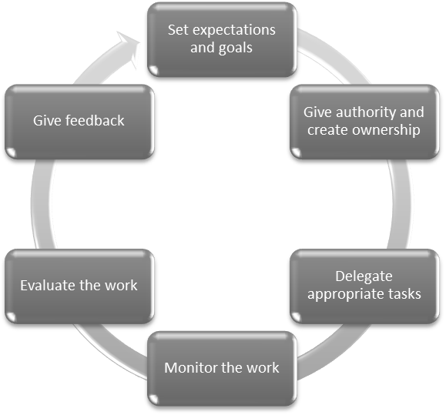
Creating Accountability

- Assess yourself and your culture
- Know your role: Request a job description if you don’t have one
- Be honest
- Apologize
- Use time wisely: Procrastination is a common way to avoid responsibility, as it delays dealing with a problem, meaning that someone else may solve it instead. Your colleagues may feel that they can’t rely on you, and this will affect your professional reputation.
- Don't overcommit: When you take on too much, something will eventually fall through the cracks. That means that you've let someone down.
- Recognize and combat the “victim cycle”
- Be solution oriented
- Make changes: When something hasn’t gone to plan, ask for feedback, and look for ways to do things differently in the future.

Job Search

Assess Your Skills

- Hard skills
  - Specific, teachable abilities that can be defined and measured
  - Typing, writing, math, reading and the ability to use software programs and machinery/tools
- Soft skills
  - Less tangible and harder to quantify
  - Personality-driven skills
  - Etiquette, getting along with others, active listening, critical thinking, conflict resolution, etc.
- Many advanced manufacturing companies will tell you that strong soft skills are as important or are more important than hard skills
- 90% of Massachusetts advanced manufacturing companies will train someone with the right soft skills

Organize Materials

- Folder/portfolio
- Job search contact/application list
- Networking contact list
- Resume
- References

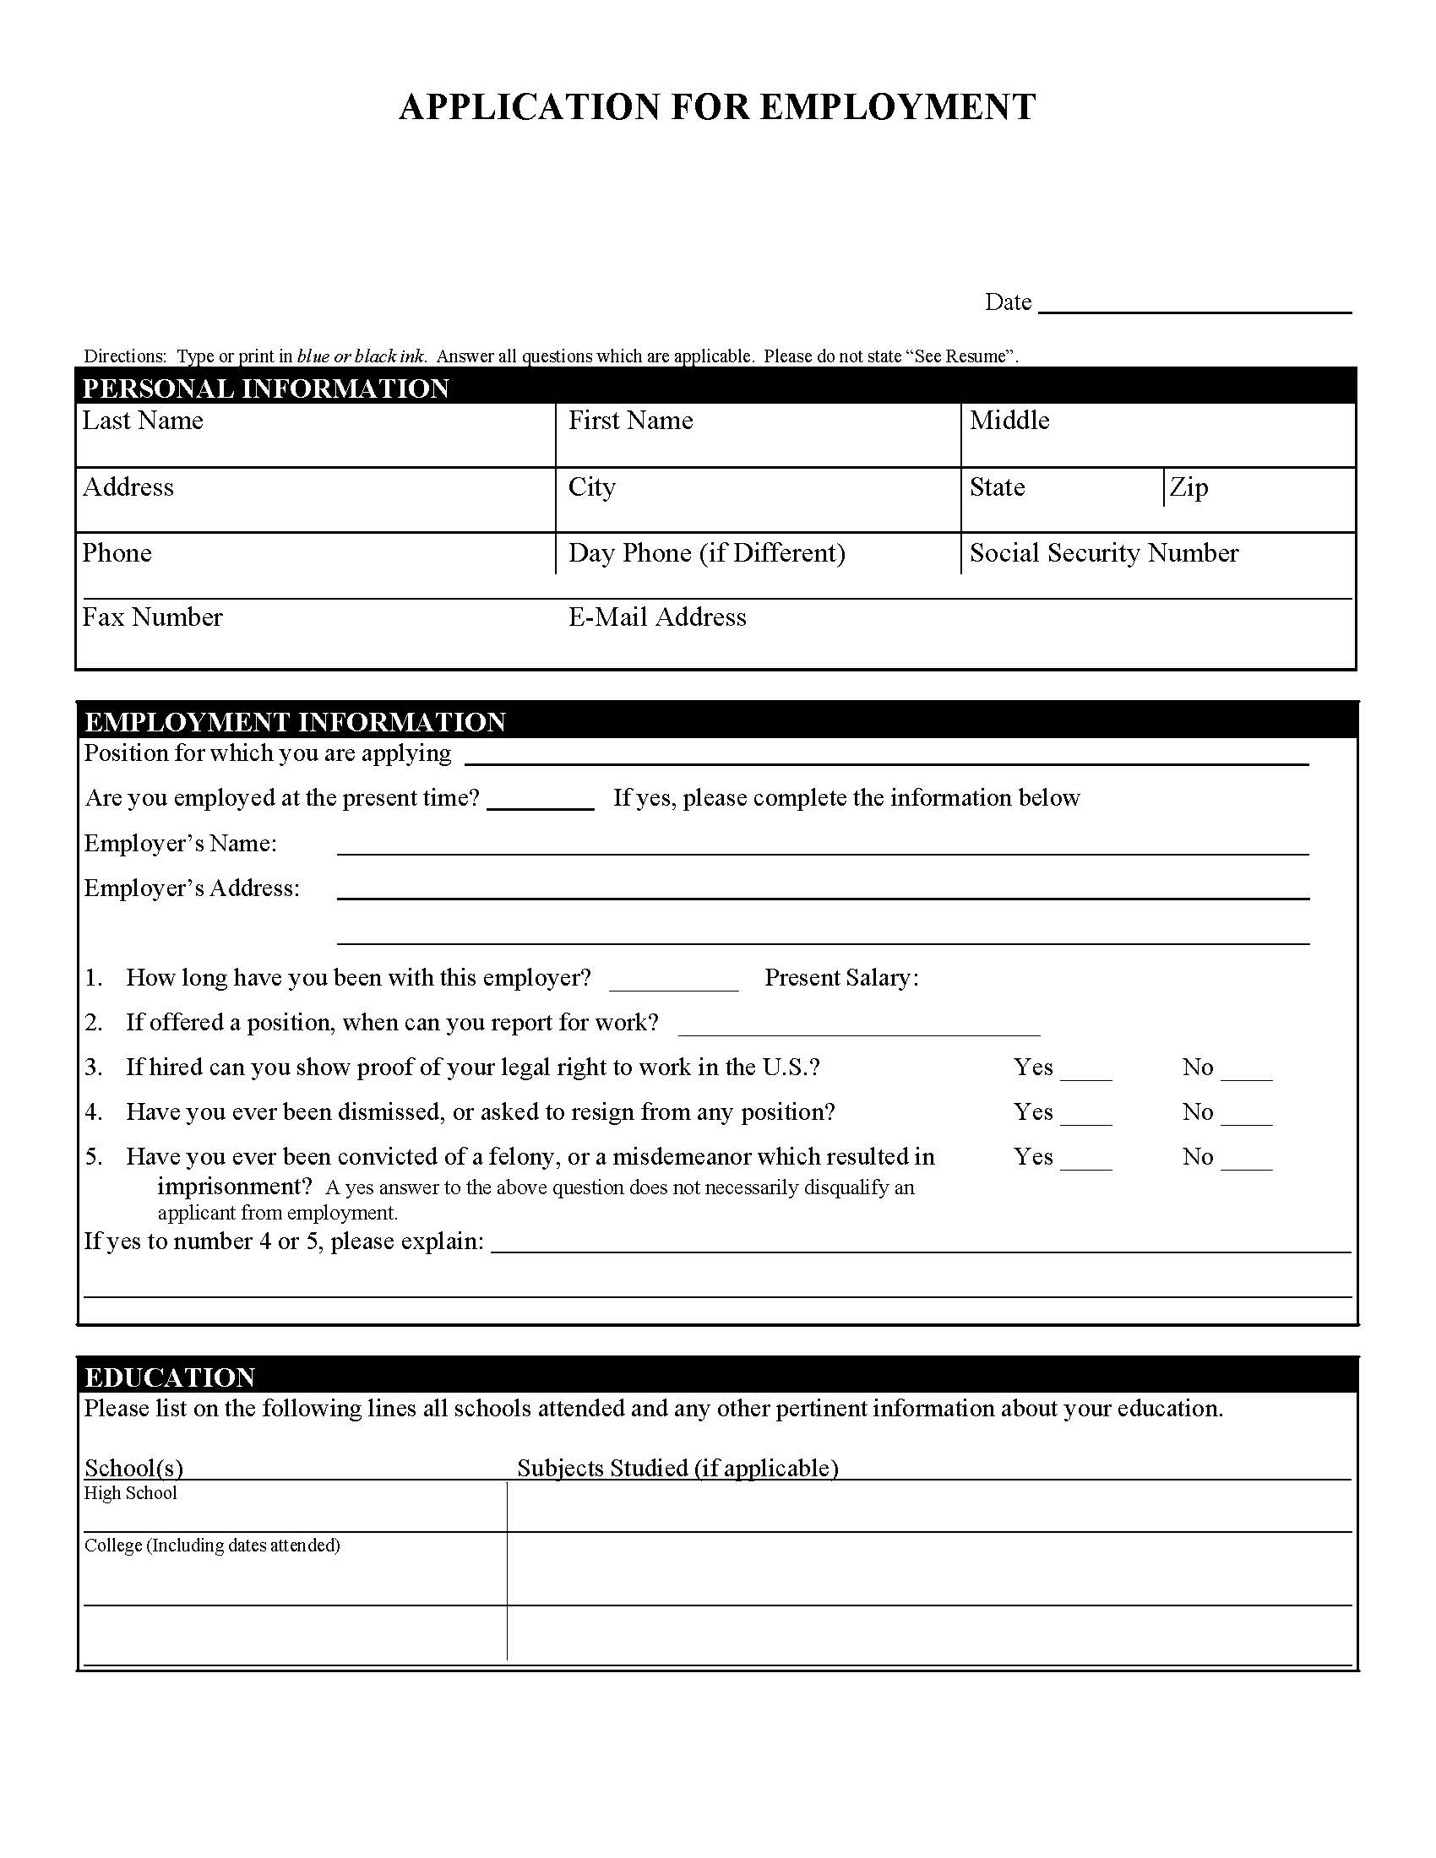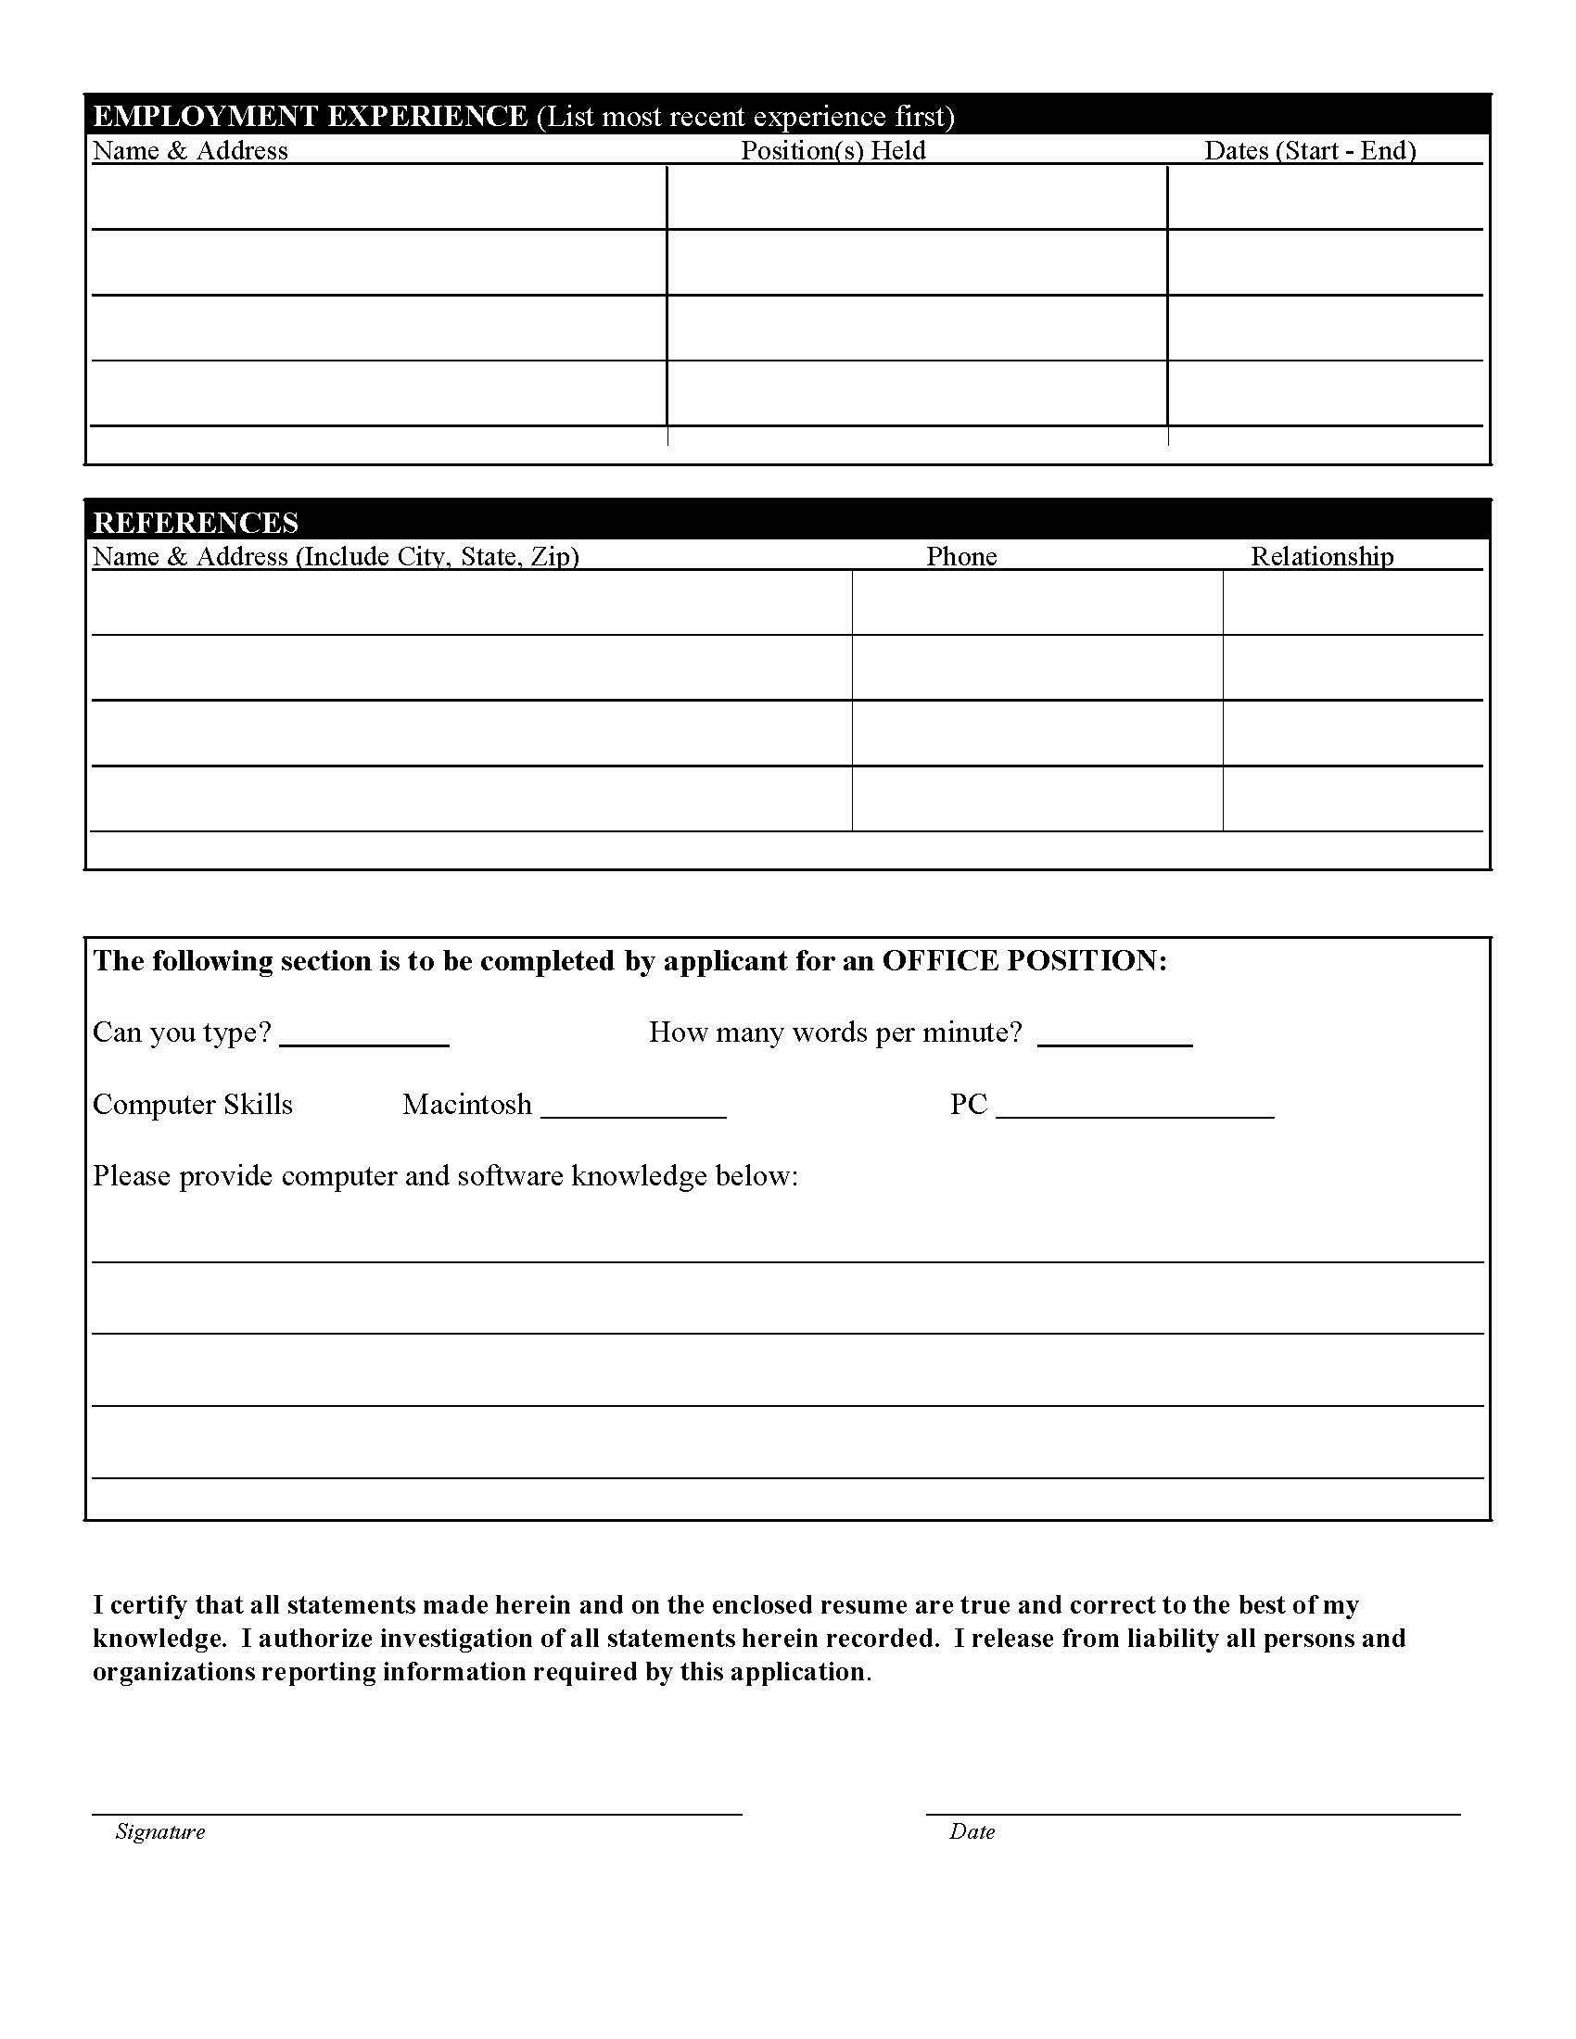

Resume and Cover Letter

Chronological Format

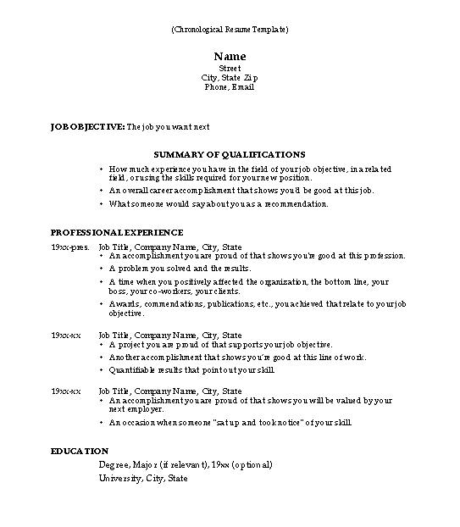

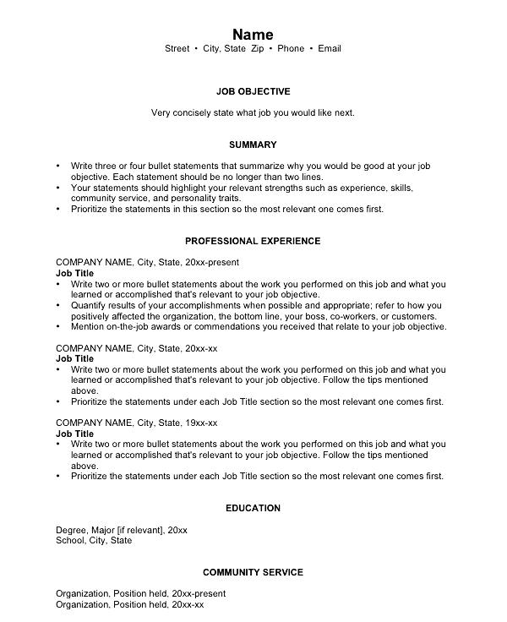

Combination Format
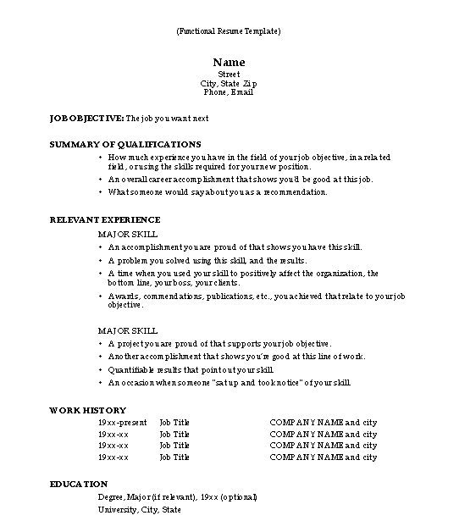

Cover Letter

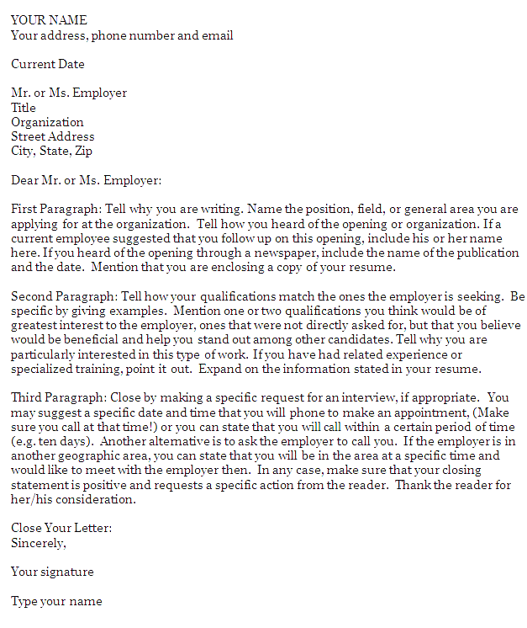

Interviewing

Before the Interview

- Review the job description or posting
- Research the company
  - Website: mission statement, products, management
  - Web search
  - Company literature
  - Contacts within the company
- Write down your questions about the company

What to Take to the Interview

- Extra copies of your resume and list of references
- Note pad or notebook
- Pens
- List of questions
- Sample application
- Portfolio to carry your papers

Frequently Asked Interview Questions

- Tell me about yourself.

______________________________________________________________________________

______________________________________________________________________________

______________________________________________________________________________

- So, what do you know about us?

- What are you looking for in a job?

______________________________________________________________________________

______________________________________________________________________________

______________________________________________________________________________

- What are your strengths and weaknesses?

Strength: _____________________________________________________________________

Weakness: _____________________________________________________________________

- Describe a difficult situation and how you resolved it.

Problem: ______________________________________________________________________

Action you took: ________________________________________________________________

Outcome: _____________________________________________________________________

- Where do you see yourself in five years?

______________________________________________________________________________

______________________________________________________________________________

______________________________________________________________________________
Asking Questions

- Develop questions or comments with substance and relevance
- Ask about specific job duties
- Tailor questions to the position
  - What kind of safety equipment do you supply?
  - In my previous position, I read blue prints. Is blue print reading a component of this position?
  - It states in the job ad that I would be troubleshooting any problems with the machinery. Can you tell me more about that?
- What is your timeframe for hiring?

