Basic Spreadsheet Concepts

Directions:
Create a spreadsheet and format it to look like the sample below.

Steps:

- Type in all text and numbers shown in the spreadsheet below.
- Format all numbers as a currency.
- Center the spreadsheet heading 'Sales for the Month' across the spreadsheet.
- Format all text as displayed in the sample below.
- Create formulas to display a total for each sales rep.
- Create formulas to display a total for each product.
- Create a formula to calculate the total sales for all sales rep's for the month.

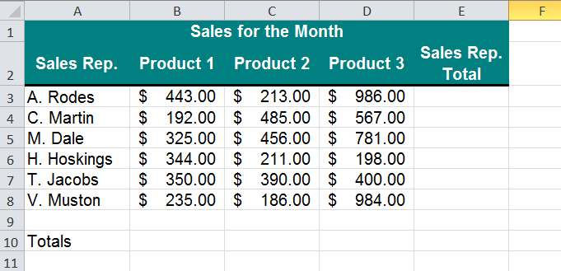

The AMMQC program is an Equal Opportunity program. Adaptive equipment is available upon request for individuals with disabilities. This workforce product was funded by a grant awarded by the U.S. Department of Labor’s Employment and Training Administration. The product was created by the grantee and does not necessarily reflect the official position of the U.S. Department of Labor. The U.S. Department of Labor makes no guarantees, warranties, or assurances of any kind, express or implied, with respect to such information, including any information on linked sites and including, but not limited to, accuracy of the information or its completeness, timeliness, usefulness, adequacy, continued availability, or ownership.

This work is licensed under a Creative Commons Attribution 3.0 Unported License [http://creativecommons.org/licenses/by/3.0]

