Dimensional Trend Report

Directions:
Using the data on the following page create a spread sheet, charts and analyze the data to answer the questions using the charts.

Steps:
- Create a spreadsheet with the measurement data
  - Find the Average for each measurement column
  - Find the Mean for each measurement column
  - Find the Standard deviation for each measurement column

- Create a scatter plot chart with points for the 20 sample measurements for dimension A
  - Insert red solid lines for the Upper & Lower Spec Tolerance limits
  - Insert blue dashed lines for the Upper & Lower Control limits
  - Using text boxes label the lines in step 2b & 2c

- Create a scatter plot chart with smooth lines and markers using the 20 sample measurements for dimension C
  - Insert red solid lines for the Upper & Lower Spec Tolerance limits
  - Insert blue dashed lines for the Upper & Lower Control limits
  - Using text boxes label the lines in strep 2b & 2c

- Answer the following Questions:
  - What can you tell about the manufacturing process in step 2
  - What can you tell from the scatter plot in step 3 about the manufacturing process

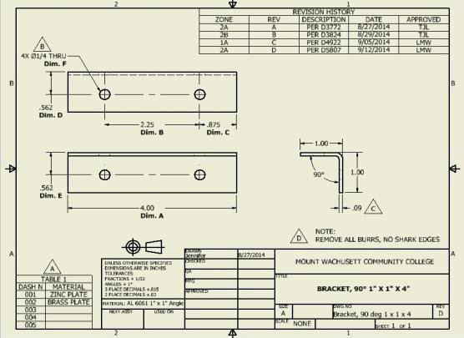

Control Limits | Dimensions Specifications
 | A | B | C | D | E
Spec. | 4.00 | 2.25 | 0.875 | 0.562 | 0.562
Upper | 4.02 | 2.27 | 0.890 | 0.577 | 0.577
Lower | 3.98 | 2.23 | 0.860 | 0.547 | 0.547
Measurement Data
Sample No. | Dimension
 | A | B | C | D | E
1 | 3.99 | 2.25 | 0.875 | 0.562 | 0.563
2 | 4.01 | 2.25 | 0.875 | 0.547 | 0.561
3 | 3.98 | 2.25 | 0.876 | 0.544 | 0.549
4 | 3.98 | 2.26 | 0.876 | 0.548 | 0.564
5 | 4.01 | 2.25 | 0.875 | 0.577 | 0.562
6 | 4.02 | 2.22 | 0.876 | 0.545 | 0.549
7 | 3.97 | 2.25 | 0.875 | 0.546 | 0.560
8 | 4.00 | 2.26 | 0.876 | 0.545 | 0.562
9 | 4.01 | 2.26 | 0.876 | 0.544 | 0.561
10 | 4.02 | 2.27 | 0.876 | 0.546 | 0.563
11 | 4.00 | 2.26 | 0.877 | 0.547 | 0.572
12 | 3.98 | 2.25 | 0.877 | 0.544 | 0.561
13 | 4.00 | 2.24 | 0.879 | 0.577 | 0.563
14 | 3.99 | 2.25 | 0.879 | 0.560 | 0.562
15 | 3.98 | 2.26 | 0.881 | 0.544 | 0.572
16 | 3.99 | 2.23 | 0.884 | 0.549 | 0.590
17 | 4.01 | 2.25 | 0.889 | 0.547 | 0.561
18 | 4.03 | 2.24 | 0.894 | 0.544 | 0.563
19 | 4.02 | 2.26 | 0.903 | 0.545 | 0.560
20 | 4.00 | 2.27 | 0.915 | 0.546 | 0.562
Average
Median
Standard Deviation
The AMMQC program is an Equal Opportunity program. Adaptive equipment is available upon request for individuals with disabilities. This workforce product was funded by a grant awarded by the U.S. Department of Labor’s Employment and Training Administration. The product was created by the grantee and does not necessarily reflect the official position of the U.S. Department of Labor. The U.S. Department of Labor makes no guarantees, warranties, or assurances of any kind, express or implied, with respect to such information, including any information on linked sites and including, but not limited to, accuracy of the information or its completeness, timeliness, usefulness, adequacy, continued availability, or ownership.

This work is licensed under a Creative Commons Attribution 3.0 Unported License [http://creativecommons.org/licenses/by/3.0]

