Parts of a Drawing Exercise – Part 1
Given the drawing on the next page, answer the following questions using short, complete statements.

Question | Answer
- Give the drawing title.
- Identify the drawing number.
- How many times has this drawing been revised?
- How many sheets are there with this drawing?
- What is the drawing scale?
- Identify the sheet size.
- Give the material used to make the part.
- Identify the view projection used on this drawing.
- Specify the finish used for this part.
- Give the initials of the person who approved this drawing.

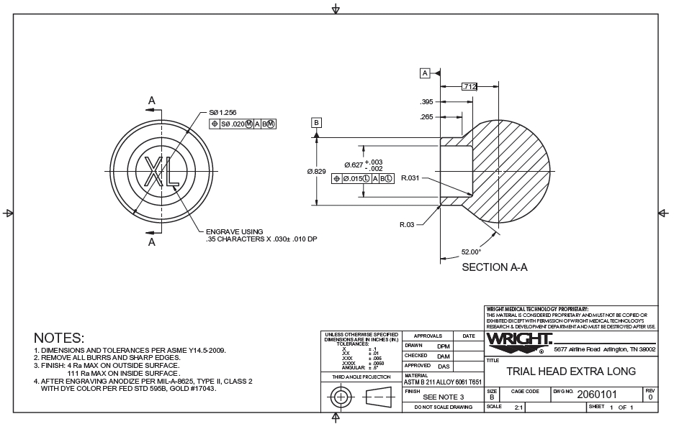

Parts of a Drawing Exercise – Part 2
Given the drawing below, answer the following questions using short, complete statements.
Question | Answer
- Give the drawing title.
- Identify the drawing number.
- How many times has this drawing been revised?
- How many sheets are there with this drawing?
- What is the drawing scale?
- Identify the zone where the (2X 46.3) dimension is located.
- Give the company name.
- Identify the view projection used on this drawing.
- Give the sheet size.
- Give the initials of the person who approved this drawing.
- Give the description of the first revision.
- Give the description of the second revision.
- Give the description of the current revision.
- Identify the zone where the second part of revision B is located.
- Identify the zone where the (58.5) dimension is located.
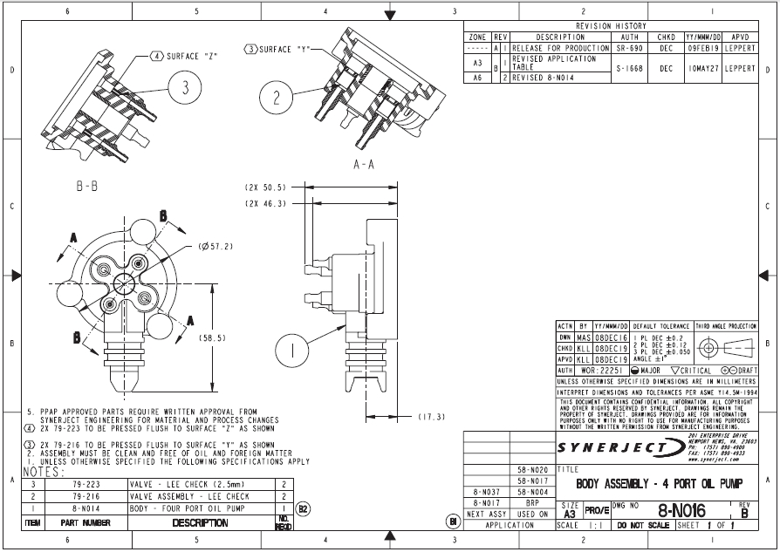

This project is sponsored by a $15.9 million grant from the U.S. Department of Labor, Employment and Training Administration.

The AMMQC program is an Equal Opportunity program. Adaptive equipment is available upon request for individuals with disabilities. This workforce product was funded by a grant awarded by the U.S. Department of Labor’s Employment and Training Administration. The product was created by the grantee and does not necessarily reflect the official position of the U.S. Department of Labor. The U.S. Department of Labor makes no guarantees, warranties, or assurances of any kind, express or implied, with respect to such information, including any information on linked sites and including, but not limited to, accuracy of the information or its completeness, timeliness, usefulness, adequacy, continued availability, or ownership.

This work is licensed under a Creative Commons Attribution 3.0 Unported License [http://creativecommons.org/licenses/by/3.0]

