Directions: Answer the questions as completely as possible.
Answer the following 10 questions as you refer to the print shown for drawing 1.1
- What does the symbol □ mean? ______________________________________________
- What is the tolerance for the 6.35 dimension? ___________________________________
- Is this drawing in inches or millimeters and how can you tell? ________________________________________________________________________
- Give the location dimensions to the Ø2.50 feature: _______________________________
- Name the material used to make this part: ______________________________________
- What is the specified surface finish? ___________________________________________
- What are the overall dimensions of this part? ____________________________________
- What standard views are shown in this drawing? _________________________________
- At what revision level is this drawing? _________________________________________
- What size drawing is this when printed at full size? _______________________________
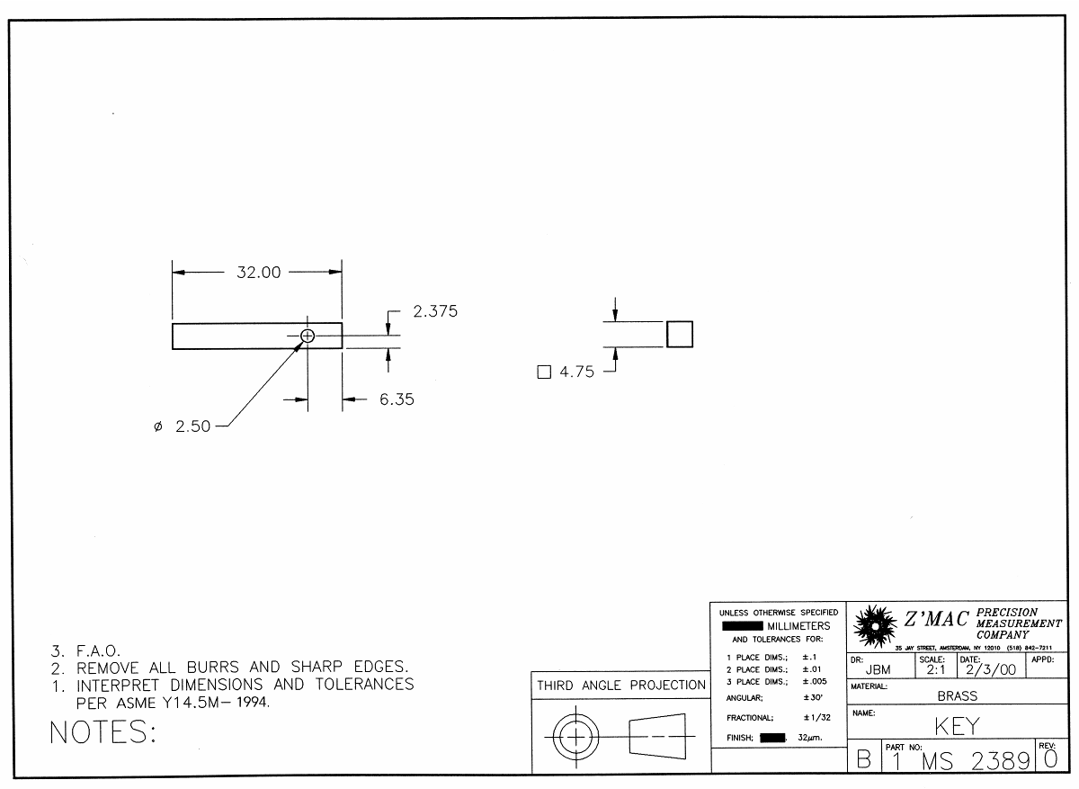
Drawing 1.1
Answer the following 10 questions as you refer to the print shown for drawing 1.2
- Why is only one view needed for this drawing? ________________________________________________________________________
- What is the overall length of the part? _________________________________________
- What is the diameter of the feature to the right of the tapered end? __________________
- Give the LIMITS of the dimension for the hole through the part: ____________________
- Give the tolerance of the Ø.187 hole: __________________________________________
- What is the tolerance of the 10º angle? _________________________________________
- What is the surface finish of this part? _________________________________________
- What is the chamfer specification? ____________________________________________
- What type of dimensioning is used to dimension the features along the length of this part? _________________________________________________________________________
- What is the specification for the threaded portion of the part? _______________________

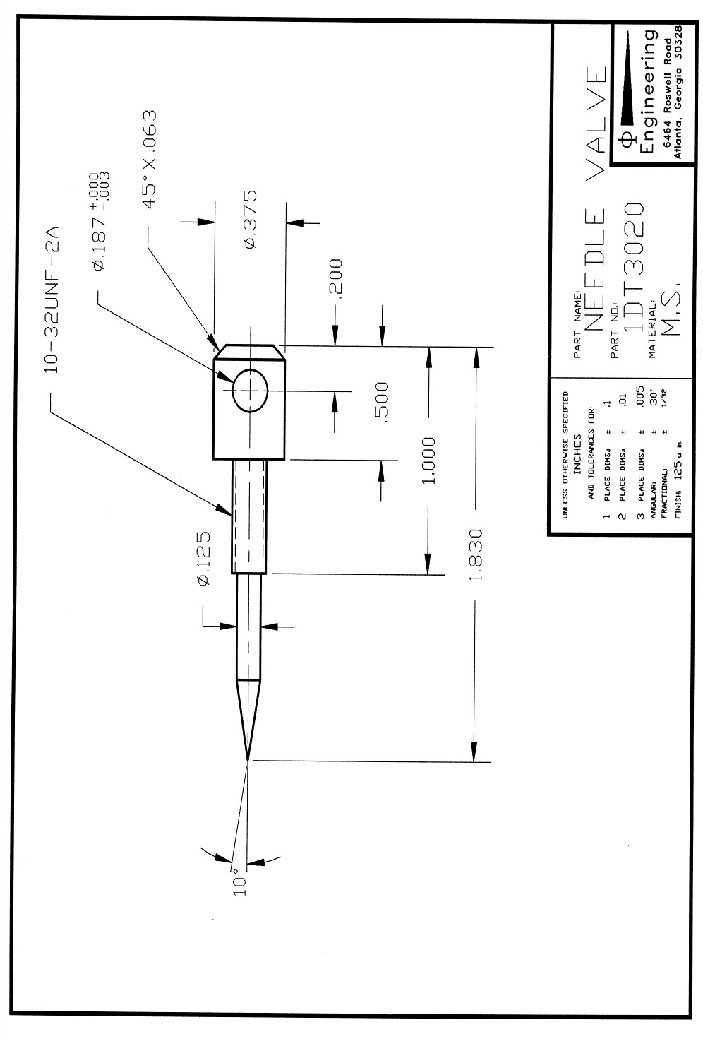
Drawing 1.2
Answer the following 10 questions as you refer to the print shown for drawing 1.3
- Why is only one view needed for this drawing? ________________________________________________________________________
- What are the overall dimensions for this part? ___________________________________
- How many holes are there in this part? ________________________________________
- How many chamfers are there on this part? _____________________________________
- What is the specification for the chamfer? ______________________________________
- Give the tolerance for the .375 dimension: _____________________________________
- What type of dimensioning is used to locate the holes in the X-axis? _________________
- What material is this part made out of? _________________________________________
- What is the finish specification for this part and where does it apply? _________________________________________________________________________
- Are these dimensions in inches or millimeters? How do you know? _________________________________________________________________________

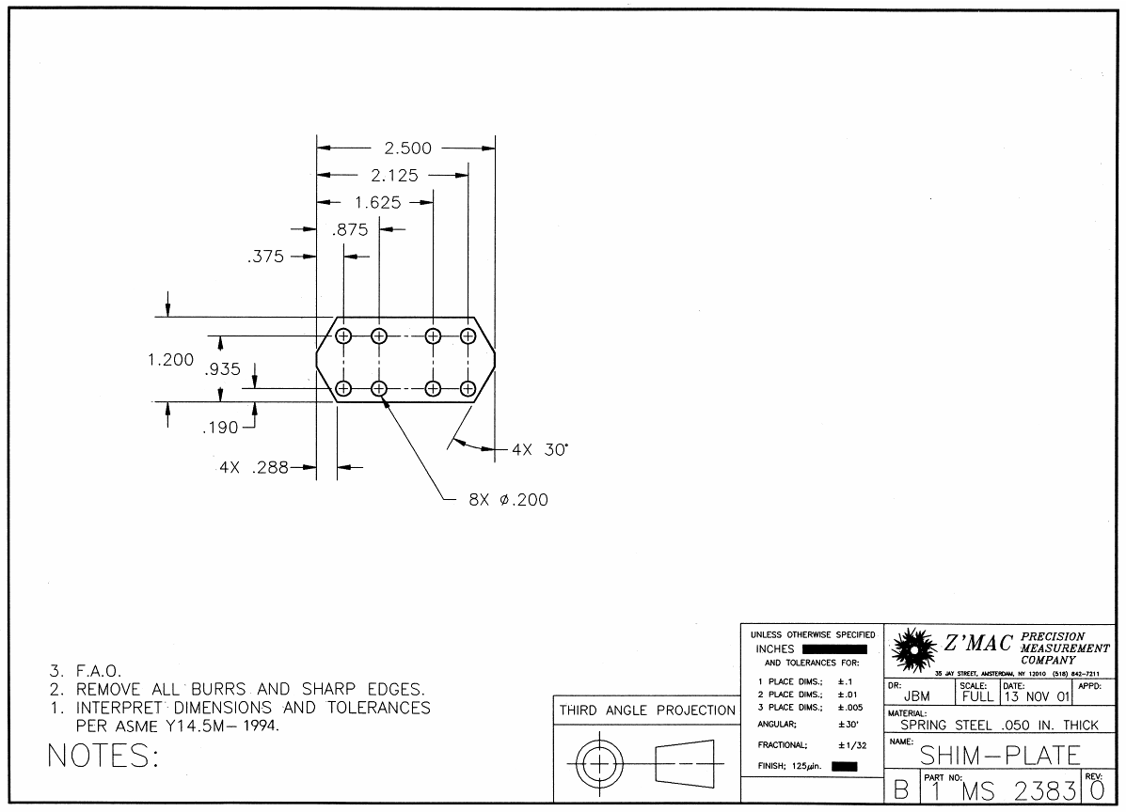
Drawing 1.3
Answer the following 10 questions as you refer to the print shown for drawing 1.4
- Which standard views are shown for this part? __________________________________
- What are the overall dimensions of this part? ___________________________________
- What are the hole specifications? _____________________________________________
- What does the SR.375 dimension mean? _______________________________________
- What is the tolerance for the .328 dimension? ___________________________________
- What are the LIMITS for the .328 dimension? ___________________________________
- What is the chamfer specification? ____________________________________________
- What is the part number for this drawing? ______________________________________
- What is the specified finish for this part? _______________________________________
- What is the length of the knurled feature? _______________________________________

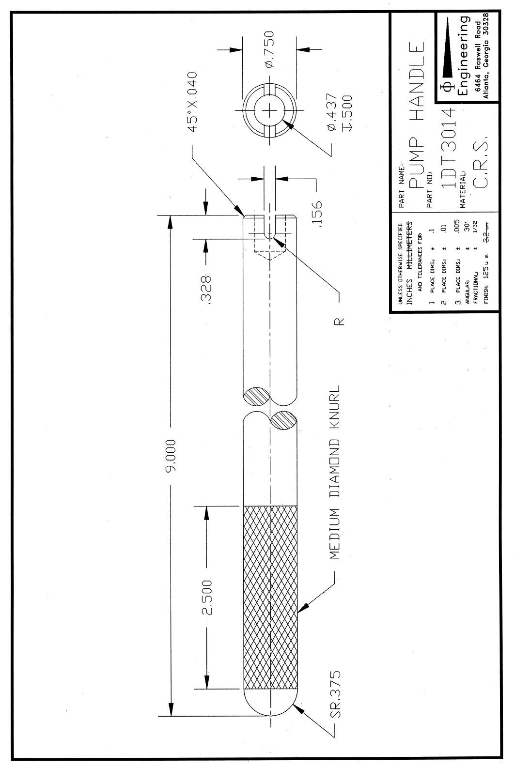
Drawing 1.4
Answer the following 10 questions as you refer to the print shown for drawing 1.5
- How many total sheets are in this set of working drawings? _________________________
- Give the dimension across the flats of the hexagon: ________________________________
- On sheet 4, what is the dimensional width for the neck feature? ______________________
- One of the parts has a rounded end. What is the dimension for the radius? _____________
- What is the height of the stamped letter? ________________________________________
- What is the overall length of the part on sheet 1? __________________________________
- What is the depth of the stamped letter? _________________________________________
- One of the optional parts has an angled recessed feature. What is the angle? ____________
- What is the surface finish specified for the feature in question 8? _____________________
- What type of dimensioning system is used to dimension the features along the length of the part? __________________________________________________________________________
Bonus: Why isn’t there a general note or title block note that specifies tolerances on this drawing? ________________________________________________________________________________

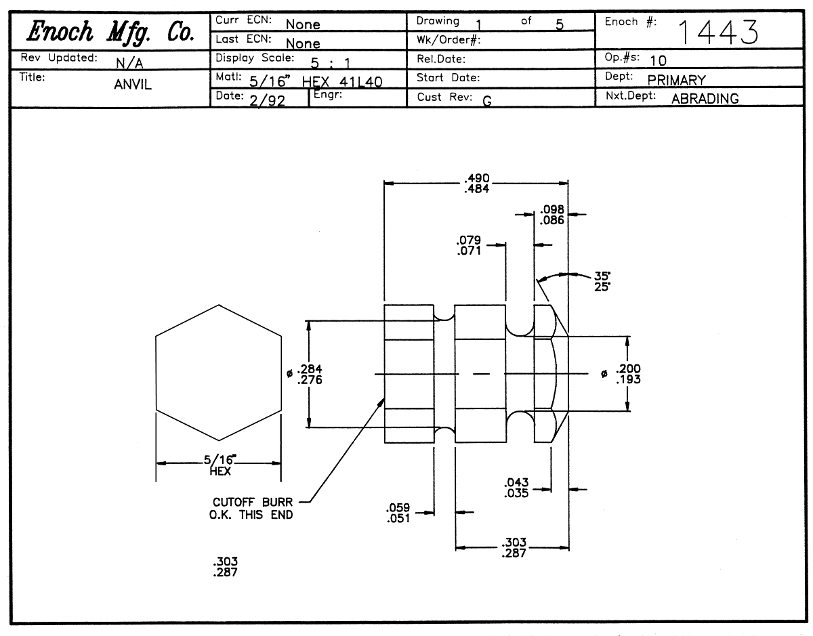

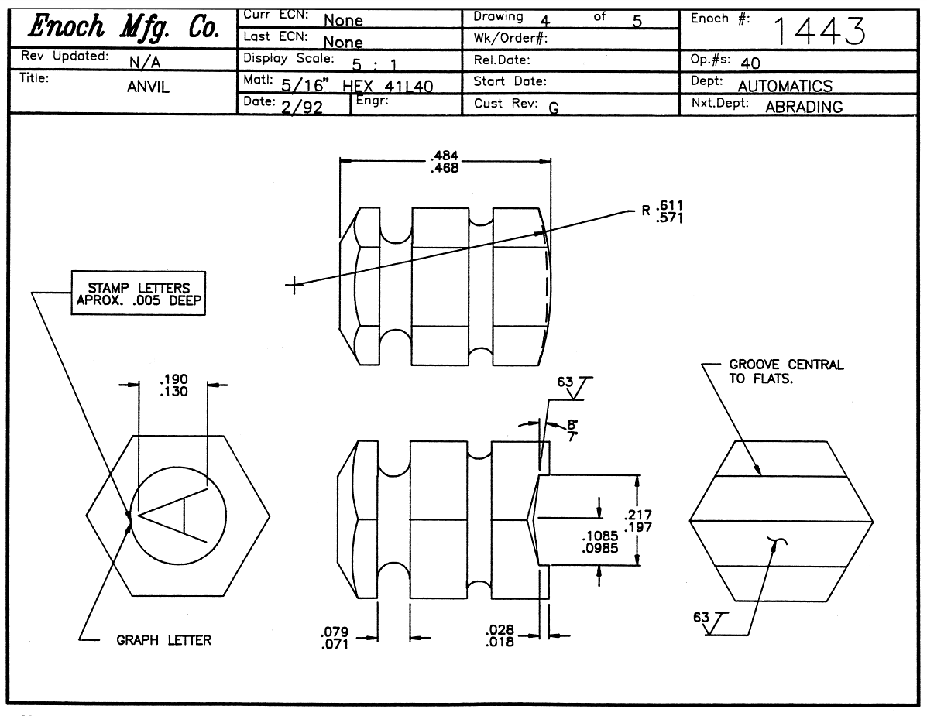

This project is sponsored by a $15.9 million grant from the U.S. Department of Labor, Employment and Training Administration.

The AMMQC program is an Equal Opportunity program. Adaptive equipment is available upon request for individuals with disabilities. This workforce product was funded by a grant awarded by the U.S. Department of Labor’s Employment and Training Administration. The product was created by the grantee and does not necessarily reflect the official position of the U.S. Department of Labor. The U.S. Department of Labor makes no guarantees, warranties, or assurances of any kind, express or implied, with respect to such information, including any information on linked sites and including, but not limited to, accuracy of the information or its completeness, timeliness, usefulness, adequacy, continued availability, or ownership.

This work is licensed under a Creative Commons Attribution 3.0 Unported License [http://creativecommons.org/licenses/by/3.0]
Drawing 1.5

