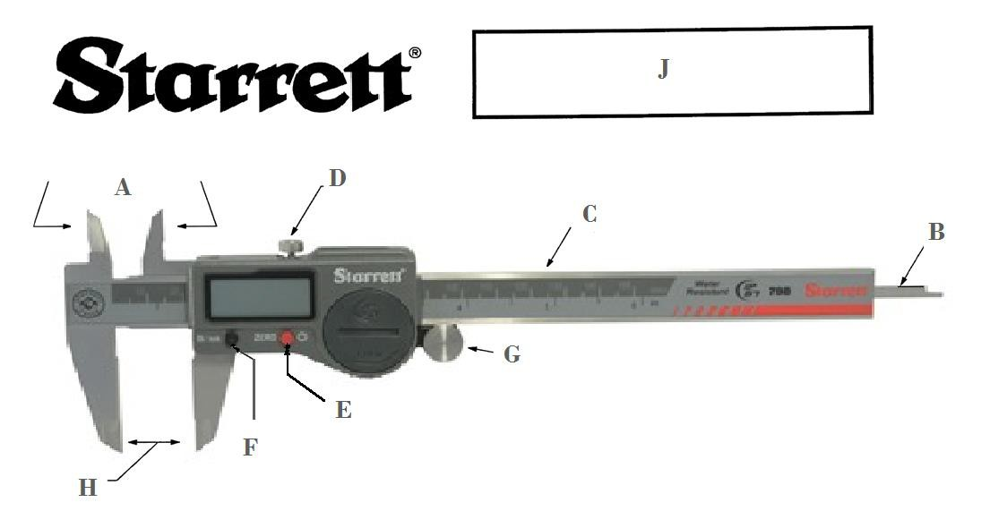

What is the correct letter for each part listed below?

Bar Outside Measuring Contacts

Locking screw in/mm Conversion

Depth rod Zero Button

Inside measuring contacts Fine Adjusting Roll

What is this tool called?

What is the correct letter for each part listed below?

C Bar H Outside Measuring Contacts

D Locking screw F in/mm Conversion

B Depth rod E Zero Button

A Inside measuring contacts G Fine Adjusting Roll

What is this tool called? Electronic Digital Caliper

The AMMQC program is an Equal Opportunity program. Adaptive equipment is available upon request for individuals with disabilities. This workforce product was funded by a grant awarded by the U.S. Department of Labor’s Employment and Training Administration. The product was created by the grantee and does not necessarily reflect the official position of the U.S. Department of Labor. The U.S. Department of Labor makes no guarantees, warranties, or assurances of any kind, express or implied, with respect to such information, including any information on linked sites and including, but not limited to, accuracy of the information or its completeness, timeliness, usefulness, adequacy, continued availability, or ownership.

This work is licensed under a Creative Commons Attribution 3.0 Unported License [http://creativecommons.org/licenses/by/3.0]

