Name Date

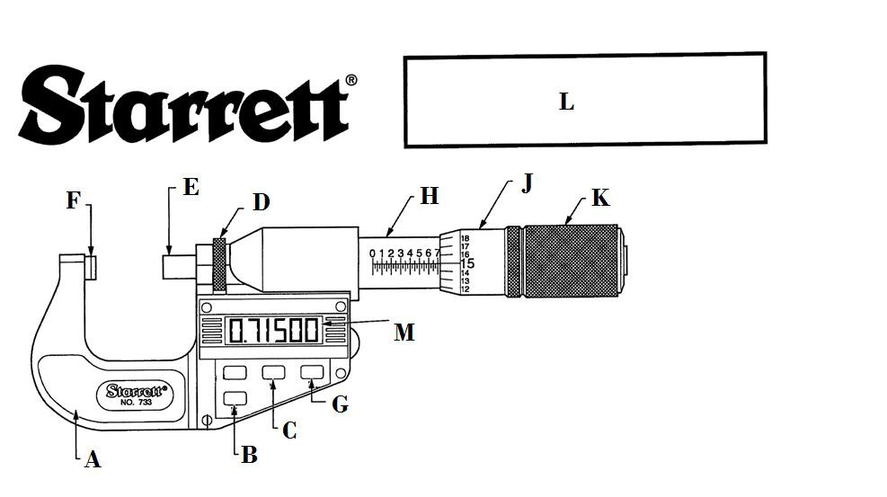

What is the correct letter for each part listed below?

Anvil Hold Reading

Spindle In/mm Conversion

Sleeve Zero Button

Thimble Frame

Friction Thimble Lock Nut

LCD Digital Display

What is this tool called?

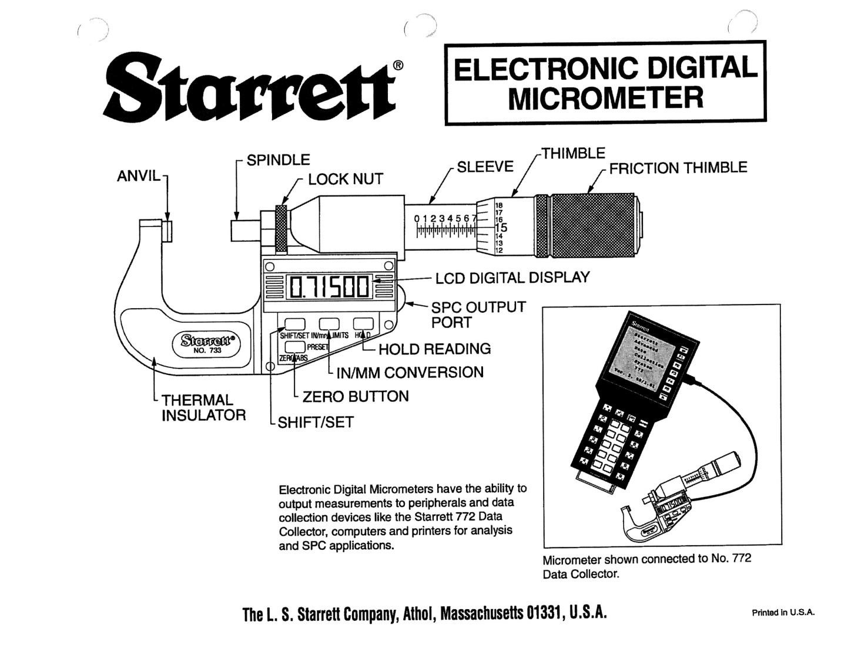
Answer Key

What is the correct letter for each part listed below?

F Anvil G Hold

E Spindle C In/mm Conversion

H Sleeve B Zero

J Thimble A Frame

K Friction Thimble D Lock Nut

M LCD Digital Display

What is this tool called? Electronic Digital Micrometer.

The AMMQC program is an Equal Opportunity program. Adaptive equipment is available upon request for individuals with disabilities. This workforce product was funded by a grant awarded by the U.S. Department of Labor’s Employment and Training Administration. The product was created by the grantee and does not necessarily reflect the official position of the U.S. Department of Labor. The U.S. Department of Labor makes no guarantees, warranties, or assurances of any kind, express or implied, with respect to such information, including any information on linked sites and including, but not limited to, accuracy of the information or its completeness, timeliness, usefulness, adequacy, continued availability, or ownership.

This work is licensed under a Creative Commons Attribution 3.0 Unported License [http://creativecommons.org/ licenses/by/3.0]

