4 BAR LINKAGE
WORK SHEET
Name:____________________________________ Date:_____________
Directions:
Use the “4 Bar Linkage Assembly” as shown below to answer the following problems. Adjust the lengths of the bars as described in each problem then, rotate the crank.
Under results, describe in detail what you see happening to the mechanism, when you rotated the crank.

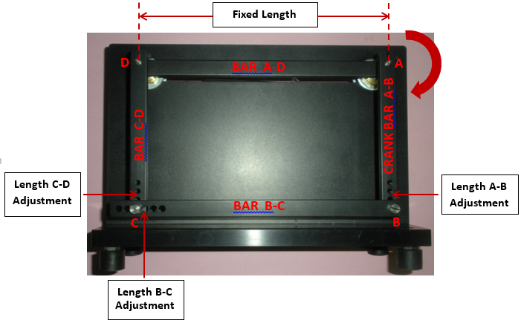

Situation Results

- Bar B-C = Bar A-D ___________________________ _____
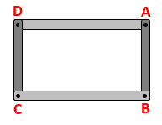
Bar A-B = Bar C-D ____________________________ ____
________________________________
________________________________
________________________________
________________________________
________________________________
________________________________

Situation Results

- Bar B-C = Bar A-D ________________________________
Bar A-B is shorter than Bar C-D ________________________________
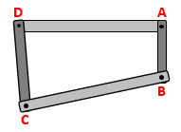
________________________________
________________________________
________________________________
________________________________
________________________________
________________________________

- Bar B-C = Bar A-D ________________________________
Bar A-B is longer than Bar C-D ________________________________
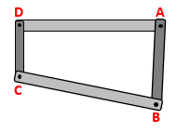
________________________________ ________________________________
________________________________
________________________________
________________________________
________________________________

- Bar B-C is shorter than Bar A-D ________________________________
Bar A-B = Bar C-D ________________________________
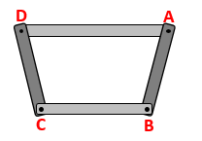
________________________________
________________________________
________________________________
________________________________
________________________________
________________________________

- Bar B-C is shorter than Bar A-D ________________________________
Bar A-B is shorter than Bar C-D ________________________________
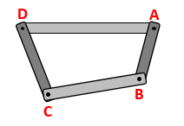
________________________________
________________________________
________________________________
________________________________
________________________________
________________________________

Situation Results

- Bar B-C is shorter than Bar A-D ________________________________
Bar A-B is longer than Bar C-D ________________________________
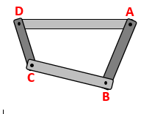
________________________________
________________________________
________________________________
________________________________
________________________________
________________________________

- Bar B-C is longer than Bar A-D ________________________________
Bar A-B = Bar C-D ________________________________
________________________________
________________________________
________________________________
________________________________
________________________________
________________________________

- Bar B-C is longer than Bar A-D ________________________________
Bar A-B is shorter than Bar C-D ________________________________
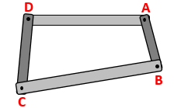
________________________________
________________________________
________________________________
________________________________
________________________________
________________________________

- Bar B-C is longer than Bar A-D ________________________________
Bar A-B is longer than Bar C-D ________________________________
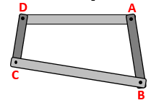
________________________________
________________________________
________________________________
________________________________
________________________________

The AMMQC program is an Equal Opportunity program.
Adaptive equipment is available upon request for individuals with disabilities.
http://creativecommons.org/licenses/by/3.0 This work is licensed under a Creative Commons Attribution 3.0 Unported License [http://creativecommons.org/licenses/by/3.0]
This project is sponsored by a $15.9 million grant from the U.S. Department of Labor, Employment and Training Administration.

The AMMQC program is an Equal Opportunity program. Adaptive equipment is available upon request for individuals with disabilities. This workforce product was funded by a grant awarded by the U.S. Department of Labor’s Employment and Training Administration. The product was created by the grantee and does not necessarily reflect the official position of the U.S. Department of Labor. The U.S. Department of Labor makes no guarantees, warranties, or assurances of any kind, express or implied, with respect to such information, including any information on linked sites and including, but not limited to, accuracy of the information or its completeness, timeliness, usefulness, adequacy, continued availability, or ownership.

