POSITION, STROKE AND TIMING
WORKSHEET

Name:________________________________________ Date:_______________

General Directions: For the following exercise use an “Elementary Timing Model”

- Using the picture below, write the corresponding letter for each of the parts listed

Turnbuckle ________ Scale ________

Sliding Plate ________ Extension Spring ________

Timing Wheel ________ Position Indicator ________
Connecting Rod ________ Guides ________
Cam Follower ________ Tapped Holes ________
Timing Indicator ________ Connector Lever ________

Cam ________ Input Shaft ________

Pivot of ________ Jamb Nut ________
Connector Lever
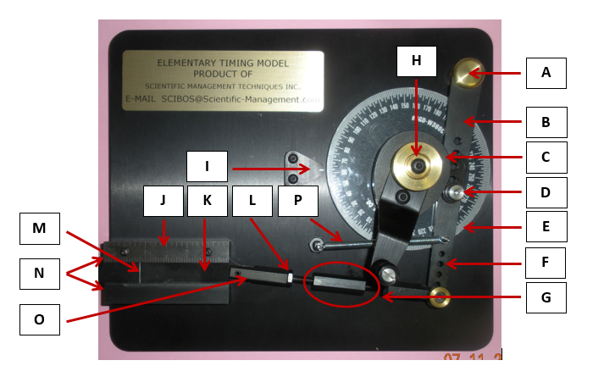
- Place the Cam Follower in each 5 positions (1-5) record the following data and summarize.

- Record the sliders position at either end of its stroke.
- Calculate the stroke
- Record the timing at the beginning and end of the stroke
- Record the dwell at the
- Summary of what effect changing the Cam followers position and the has on the sliders position, stroke and timing

Cam Follower Position | Slider Position (in.) |  |  | Timing (deg.)
 | Start | End | Stroke | Start | End | Dwell
a
b
c
d
e
Summary: ______________________________________________________________________________________________________________________________________________________________________________________________________________________________________________________________________________________________________________________________________________________________________________________________________________________________________________________________________________

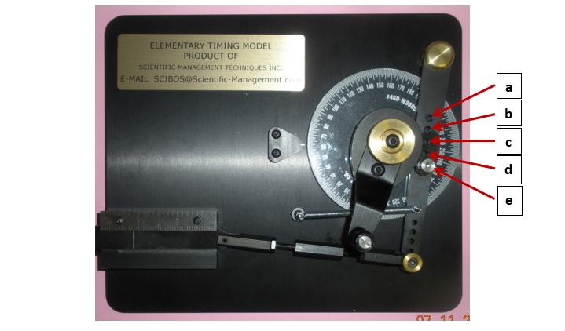
3. Attach the turnbuckle end to each of the 5 positions (1-5), record the following data and summarize
- Record the sliders position at either end of its stroke.
- Calculate the stroke
- Record the timing at the beginning and end of the stroke
- Record the dwell at the
- Summary of what effect changing the Cam followers position and the has on the sliders position, stroke and timing

Turnbuckle Position | Slider Position (in.) |  |  | Timing (deg.)
 | Start | End | Stroke | Start | End | Dwell
1
2
3
4
5
Summary: ______________________________________________________________________________________________________________________________________________________________________________________________________________________________________________________________________________________________________________________________________________________________________________________________________________________________________________________________________________

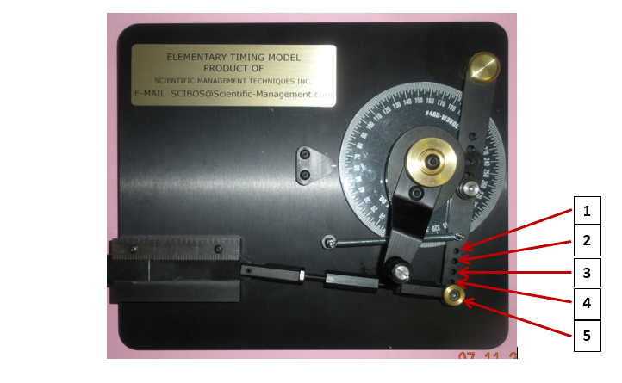
4. Adjust the turnbuckle to 5 different lengths, record the following data and summarize

- Record the sliders position at either end of its stroke.
- Calculate the stroke
- Record the timing at the beginning and end of the stroke
- Record the dwell at the
- Summary of what effect changing the Cam followers position and the has on the sliders position, stroke and timing

Turnbuckle Length | Slider Position (in.) |  |  | Timing (deg.)
 | Start | End | Stroke | Start | End | Dwell
Summary: ______________________________________________________________________________________________________________________________________________________________________________________________________________________________________________________________________________________________________________________________________________________________________________________________________________________________________________________________________________

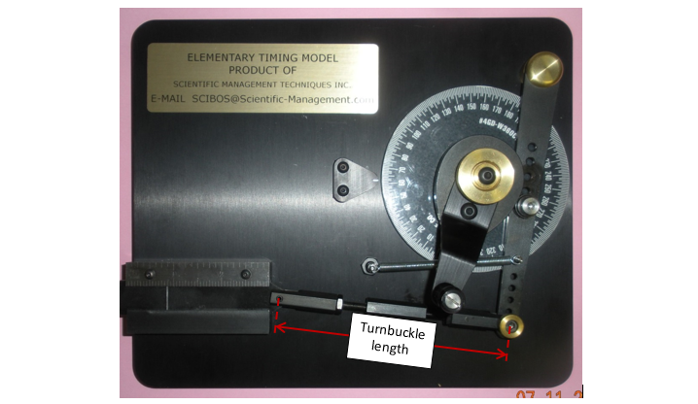
The AMMQC program is an Equal Opportunity program.
Adaptive equipment is available upon request for individuals with disabilities.
http://creativecommons.org/licenses/by/3.0 This work is licensed under a Creative Commons Attribution 3.0 Unported License [http://creativecommons.org/licenses/by/3.0]
This project is sponsored by a $15.9 million grant from the U.S. Department of Labor, Employment and Training Administration.
The AMMQC program is an Equal Opportunity program. Adaptive equipment is available upon request for individuals with disabilities. This workforce product was funded by a grant awarded by the U.S. Department of Labor’s Employment and Training Administration. The product was created by the grantee and does not necessarily reflect the official position of the U.S. Department of Labor. The U.S. Department of Labor makes no guarantees, warranties, or assurances of any kind, express or implied, with respect to such information, including any information on linked sites and including, but not limited to, accuracy of the information or its completeness, timeliness, usefulness, adequacy, continued availability, or ownership.

