MWCC
Program Name: Manufacturing Career Preparation Program
Instructors Names: Robert Wiita
Course Name: Electrical

The Electronics part of this course includes, but is not limited to, the following:

- Safety
- Metric conversions
- Resistor color code
- Intro to Basic Electronics Circuits
- Basic use of Ohms law for to determine resistance, voltage, and current
- Intro to meters in the electronics field
- How to use a DMM to test diodes and Continuity
- Use of DMM’s to measure DC Resistance, Voltage, and Current
- The difference between AC voltage and DC voltage
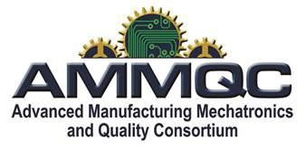

This project is sponsored by a $15.9 million grant from the U.S. Department of Labor, Employment and Training Administration. The AMMQC program is an Equal Opportunity program. Adaptive equipment is available upon request for individuals with disabilities. This workforce product was funded by a grant awarded by the U.S. Department of Labor’s Employment and Training Administration. The product was created by the grantee and does not necessarily reflect the official position of the U.S. Department of Labor. The U.S. Department of Labor makes no guarantees, warranties, or assurances of any kind, express or implied, with respect to such information, including any information on linked sites and including, but not limited to, accuracy of the information or its completeness, timeliness, usefulness, adequacy, continued availability, or ownership.

