Kirchhoff’s Laws

Purpose

1. To investigate Kirchhoff’s Voltage Law
2. To investigate Kirchhoff’s Current Law
3. To work with circuits and meters to confirm Kirchhoff’s Voltage and Current Laws

Equipment

Breadboard, resistors, hook up wires

Multimeter (ammeter, voltmeter )

Procedure

Kirchhoff’s Laws apply to voltage and current found in series and parallel loops.

A loop is any closed path in a circuit. It is a path which allows electrons to leave a power source, travel through the elements in the path and then back to the power source. Some important things to remember:

* A SERIES circuit is a loop.
* Elements of a circuit can be passive or active:
* Passive elements are consumers of energy (such as a Resistor, Light Bulb, Relay Coil)
* Active elements are producers of energy (such as a Battery, AC outlet, Solar Cell)

**Kirchhoff’s Voltage Law (KVL)**

Kirchhoff’s Voltage Law (KVL), first definition:

In any closed loop the sum of the voltages is always equal to zero.

Mathematical formula: VS - VR1 - VR2 - VR3 = 0

VS = Voltage Source VR1 = Voltage across R1

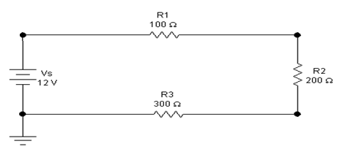

Circuit Example for Kirchhoff’s Voltage Law (KVL), First Definition:

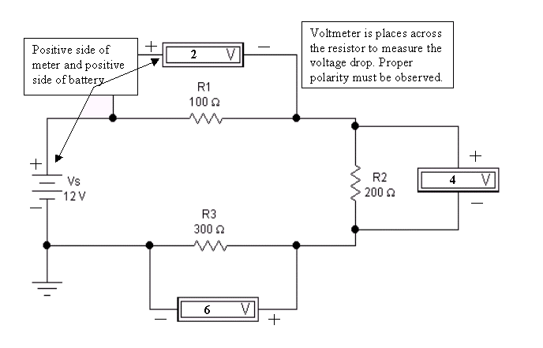

Kirchhoff’s Voltage Law (KVL), Second Definition:

In any closed loop, the sum of the sources is equal to the sum of the voltage drops.

Mathematical Formula: VS1 + VS2 = VR1 + VR2 + VR3

VS = Voltage Source VR1 = Voltage drop of R1

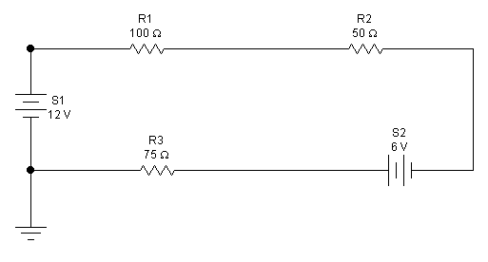

Circuit example for Kirchhoff’s Voltage Law (KVL), Second Definition: 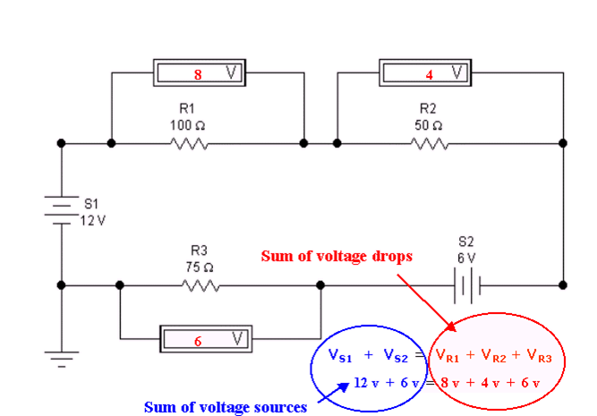

**Kirchhoff’s Current Law (KCL)**

Kirchhoff’s Current Law is a mathematical expression of the balance of currents entering and leaving a node. (A node is the intersection of more than two connectors.)

Kirchhoff’s Current Law, first definition:

The sum of all the currents entering and leaving a node is always equal to zero.

Mathematical formula: IS - I1 - I2 - I3 = 0

IS = current produced by source

I1 , I2 , I3 = currents through users of energy, such as resistors

Circuit Example for Kirchhoff’s Current Law (KCL), first definition

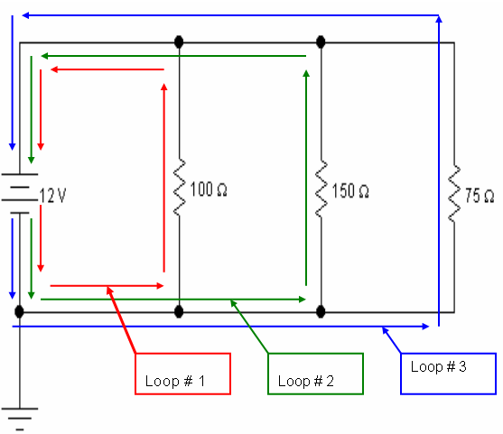

**Specific Example:**

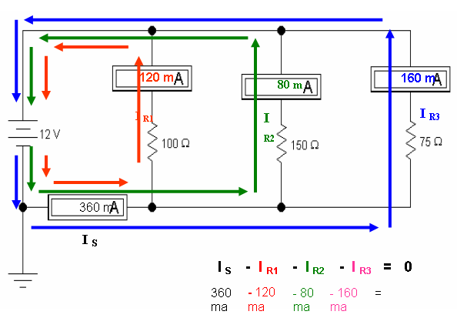

Kirchhoff’s Current Law (KCL), Second definition:

In a node, the sum of the currents entering the node is equal to the sum of the currents leaving the node.

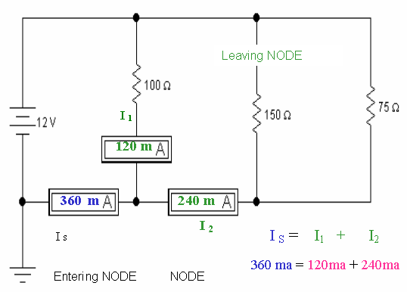

1. Using the following circuit:



**VS**

Place (draw) meters in the circuit to read: IR1 , IR2  , IR3 , VR1, VR2, VR3 ,  VS

1. Use this circuit:

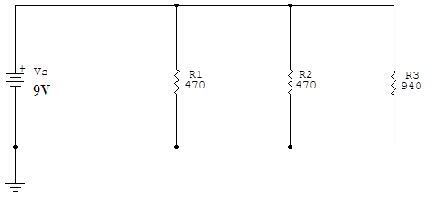

Place meters into the circuit to read: IR1 , IR2  , IR3 , VR1, VR2, VR3 ,  VS

*Demonstrate the circuit to your teacher and get signature:________________*

1. Demonstrate Kirchhoff’s current Law to the teacher. Circuit 2

*Demonstrate the circuit to your teacher and get signature:________________*

Conclusion

1. What is a NODE?
2. What is an ACTIVE ELEMENT in a circuit?
3. What is a PASSIVE ELEMENT in a circuit?
4. In your own words, what is Kirchhoff’s Voltage Law?
5. In your own words, what is Kirchhoff’s Current Law?
6. Define a Series circuit.
7. Define a Parallel circuit.

The AMMQC program is an Equal Opportunity program.

Adaptive equipment is available upon request for individuals with disabilities.

<http://creativecommons.org/licenses/by/3.0>This work is licensed under a Creative Commons Attribution 3.0 Unported License [[http://creativecommons.org/licenses/by/3.0]](http://creativecommons.org/licenses/by/3.0)

This project is sponsored by a $15.9 million grant from the U.S. Department of Labor, Employment and Training Administration.

The AMMQC program is an Equal Opportunity program. Adaptive equipment is available upon request for individuals with disabilities. This workforce product was funded by a grant awarded by the U.S. Department of Labor’s Employment and Training Administration. The product was created by the grantee and does not necessarily reflect the official position of the U.S. Department of Labor. The U.S. Department of Labor makes no guarantees, warranties, or assurances of any kind, express or implied, with respect to such information, including any information on linked sites and including, but not limited to, accuracy of the information or its completeness, timeliness, usefulness, adequacy, continued availability, or ownership.