RESISTOR COLOR CODE CHART
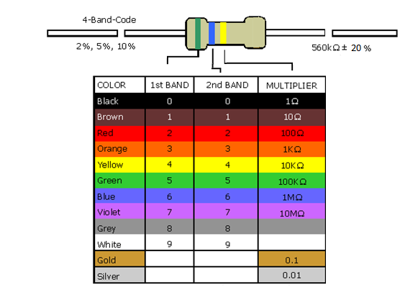

The AMMQC program is an Equal Opportunity program.
Adaptive equipment is available upon request for individuals with disabilities.
http://creativecommons.org/licenses/by/3.0 This work is licensed under a Creative Commons Attribution 3.0 Unported License [http://creativecommons.org/licenses/by/3.0]
This project is sponsored by a $15.9 million grant from the U.S. Department of Labor, Employment and Training Administration.
The AMMQC program is an Equal Opportunity program. Adaptive equipment is available upon request for individuals with disabilities. This workforce product was funded by a grant awarded by the U.S. Department of Labor’s Employment and Training Administration. The product was created by the grantee and does not necessarily reflect the official position of the U.S. Department of Labor. The U.S. Department of Labor makes no guarantees, warranties, or assurances of any kind, express or implied, with respect to such information, including any information on linked sites and including, but not limited to, accuracy of the information or its completeness, timeliness, usefulness, adequacy, continued availability, or ownership.

