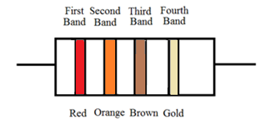
Resistor Color Code

____________ ____________ ____________ ____________ ____________
Value

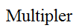
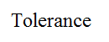
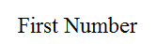
Color First Band Second Band Third Band Forth Band
Black 0 0 1
Brown 1 1 10
Red 2 2 100
Orange 3 3 1,000
Yellow 4 4 10,000
Green 5 5 100,000
Blue 6 6 1,000,000
Violet 7 7
Gray 8 8
White 9 9
Gold X.1 5%
Silver X.01 10%
No Color 20%
This project is sponsored by a $15.9 million grant from the U.S. Department of Labor, Employment and Training Administration.

The AMMQC program is an Equal Opportunity program. Adaptive equipment is available upon request for individuals with disabilities. This workforce product was funded by a grant awarded by the U.S. Department of Labor’s Employment and Training Administration. The product was created by the grantee and does not necessarily reflect the official position of the U.S. Department of Labor. The U.S. Department of Labor makes no guarantees, warranties, or assurances of any kind, express or implied, with respect to such information, including any information on linked sites and including, but not limited to, accuracy of the information or its completeness, timeliness, usefulness, adequacy, continued availability, or ownership.

This work is licensed under a Creative Commons Attribution 3.0 Unported License [http://creativecommons.org/licenses/by/3.0]

