**Testing a Potentiometer**

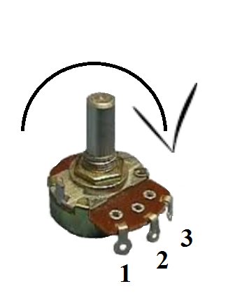

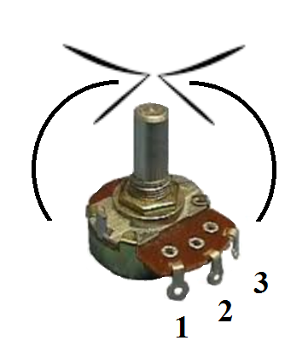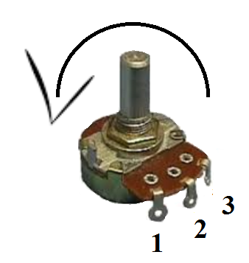

|  |  |  |  |
| --- | --- | --- | --- |
| 1 | 2 | 3 | Reading |
|  |  |  |  |
|  |  |  |  |
|  |  |  |  |

Fully CCW Fully CW Half turn

|  |  |  |  |
| --- | --- | --- | --- |
| 1 | 2 | 3 | Reading |
|  |  |  |  |
|  |  |  |  |
|  |  |  |  |

|  |  |  |  |
| --- | --- | --- | --- |
| 1 | 2 | 3 | Reading |
|  |  |  |  |
|  |  |  |  |
|  |  |  |  |

