|  |
| --- |
|  |
| Devens Color Logo.JPG  cid:image004.jpg@01D050FD.CF15BA40 |

**ADVANCED MANUFACTURING INDUSTRIAL READINESS**

**TRAINING PROGRAM**

**WAGON PROJECT**

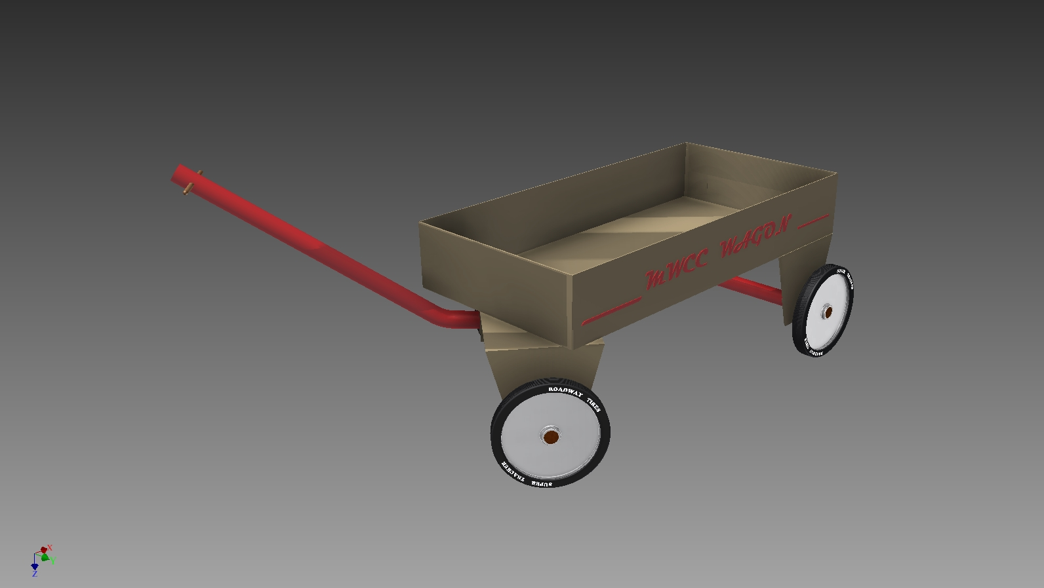

|  |
| --- |
|  |

The AMMQC program is an Equal Opportunity program.

Adaptive equipment is available upon request for individuals with disabilities.

<http://creativecommons.org/licenses/by/3.0> This work is licensed under a Creative Commons Attribution 3.0 Unported License [http://creativecommons.org/licenses/by/3.0]

This project is sponsored by a $15.9 million grant from the U.S. Department of Labor, Employment and Training Administration.

The AMMQC program is an Equal Opportunity program. Adaptive equipment is available upon request for individuals with disabilities. This workforce product was funded by a grant awarded by the U.S. Department of Labor’s Employment and Training Administration. The product was created by the grantee and does not necessarily reflect the official position of the U.S. Department of Labor. The U.S. Department of Labor makes no guarantees, warranties, or assurances of any kind, express or implied, with respect to such information, including any information on linked sites and including, but not limited to, accuracy of the information or its completeness, timeliness, usefulness, adequacy, continued availability, or ownership.

|  |
| --- |
|  |



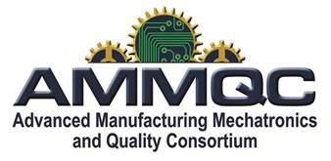

**Directions**

**General Scope:**

The manufacturing team will design the Manufacturing Process for a wagon. During the project they will consider manpower, equipment, materials, time, quality and cost associated with manufacturing the wagon.

**Set up:**

Designate a member to be each of the following:

Project Manager, Financial Manager, Process Engineer, Asset Manager and Quality Control Manager

The team will be given a sample wagon

The team will be given materials and equipment for constructing at least three wagons

The team will be given one full day to complete the project

**Process:**

1. The team will develop a schedule for completing the project on time, The Project Manager will document in a printed schedule.
2. The team will reverse engineer the prototype identifying the individual components and subassemblies. The Financial Manager will document the components in a bill of materials
3. The team will design the standard operating procedures (SOP) for fabricating the components and assemble the wagon. The Process Engineer will document the SOP in a list format
4. The team will fabricate a prototype wagon using the SOP and time each process. The Process Engineer will add the recorded times to the SOP.
5. The team will take the SOP and design a sequence allocating personnel, material, equipment and time using post-it notes on the white board. The Asset manager will document the sequence in a “Flow Chart” including times for each procedure and who will perform it. The flow chart must have columns for each employee’s procedures and arrows connecting the procedures into a sequence.
6. The team will then determine what criteria, methods and when inspections must be implemented to produce a quality wagon. The Quality Control Manager using the attached inspection report will document the “Inspection Criteria” chosen and the Asset Manager will add “the inspection procedures into the “Flow Chart” and the Process Engineer will add them into the “SOP”.
7. The team will perform a test production run of two wagons, following the “Flow Chart”, including inspections.
8. The team will review the current product design, based on usage, ability to manufacture and cost. Any recommendations will be documented in the form or sketches and written descriptions
9. The team will assemble the Manufacturing report by the end of the day along with the two wagons from the test production run.

**Production Report:**

Project Schedule

Final “Bill of Materials” with cost of Labor and materials

Final “SOP” for fabricating the product (individual operations)

Final “Flow chart” (with times for each operation)

Final “Inspection Report” for the production run of two

Comment on recommendations for design changes to product in the form of sketches and written descriptions, Changes to the SOP and Flow Chart, additional equipment needed for fabrication of the wagon and outsourcing any parts.

**Team Assignments:**

Project Manager:

Responsible for a schedule for completing the project in the time allotted.

Financial Manager:

Responsible for tracking the financial aspects of the fabrication process including labor and materials and document in a “Bill of Materials”

Process Engineer:

Responsible for documenting the “SOP” needed to fabricate the components, assemble the subassemblies and the assemble the overall wagon

Asset Manager:

Responsible for documenting the allocation of manpower, equipment and materials for the manufacturing process. “Flow Chart”

Quality Assurance manager:

Responsible for documenting the type and results of the inspections made and record the results on the “Inspection Report” form.

**Wagon Specifications:**

Wagon must have a volume of 18 cubic inches minimum

Four wheels

Steerable front wheels

Handle which can be pulled from varying heights

Weight capacity 10 oz. minimum

Dimensions per attached drawings.

**Materials**

Construction Paper

Foam core (presentation Board)

Round tooth picks

1/16” Ø dowel

3/16”Ø dowel

1/4” Ø O.D. plastic straws

3/8” Brass-plated round head fasteners

Post it pads

8 ½” x 11” copy paper

Glue Sticks (rub on)

Hot Glue Sticks

Clear tape

Spray glue

Liquid glue

Thumb tacks

**Equipment:**

Scissors

Exacto Knifes

Box cutter

Ruler

Pencils

Drawing triangles

Compass

Cutting board

Hot Glue Gun

Scale

Hole punch

**Appendix A**

**Samples**

**Sample Assembly Drawing**

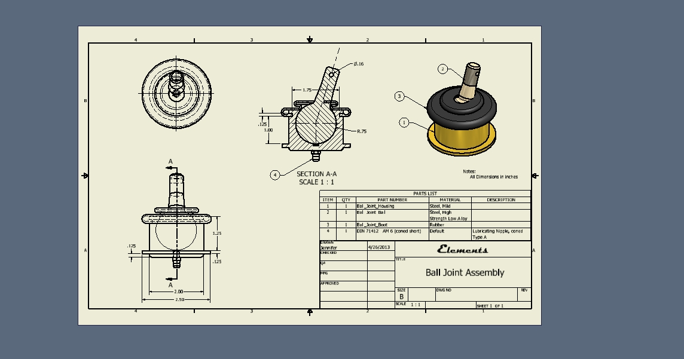

**Sample Part Drawing**

**Orthographic Projection (3Views)**

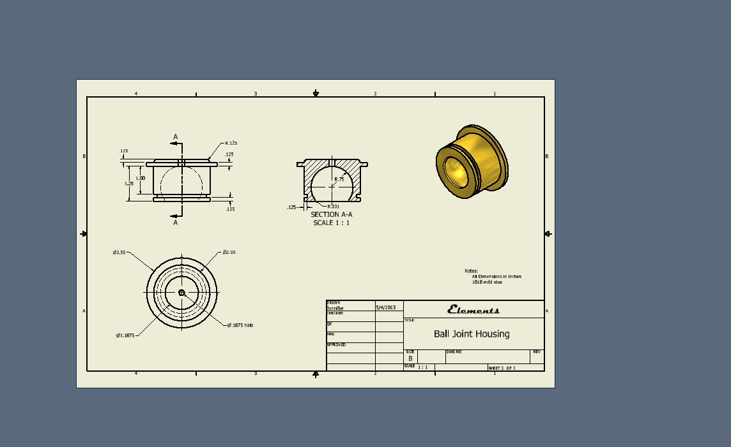

**Sample Assembly Drawing**

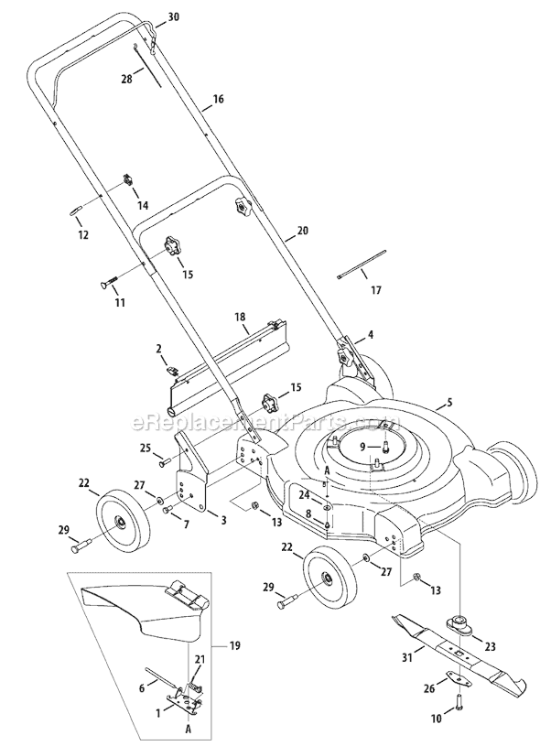

http://www.ereplacementparts.com/images/mtd/11A-074R265_(2009)_WW_1.gif

|  |
| --- |
|  |

Top of Form

**Sample Bill of Materials**



**Sample Flow Chart**

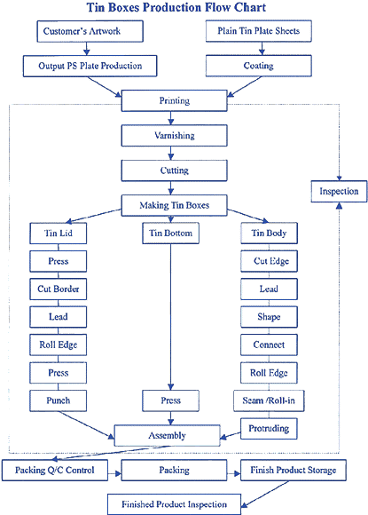

**http://www.timelesstins.com/Images/Ragan_artwork/production_flowchart.gif**

**Sample Inspection Report**

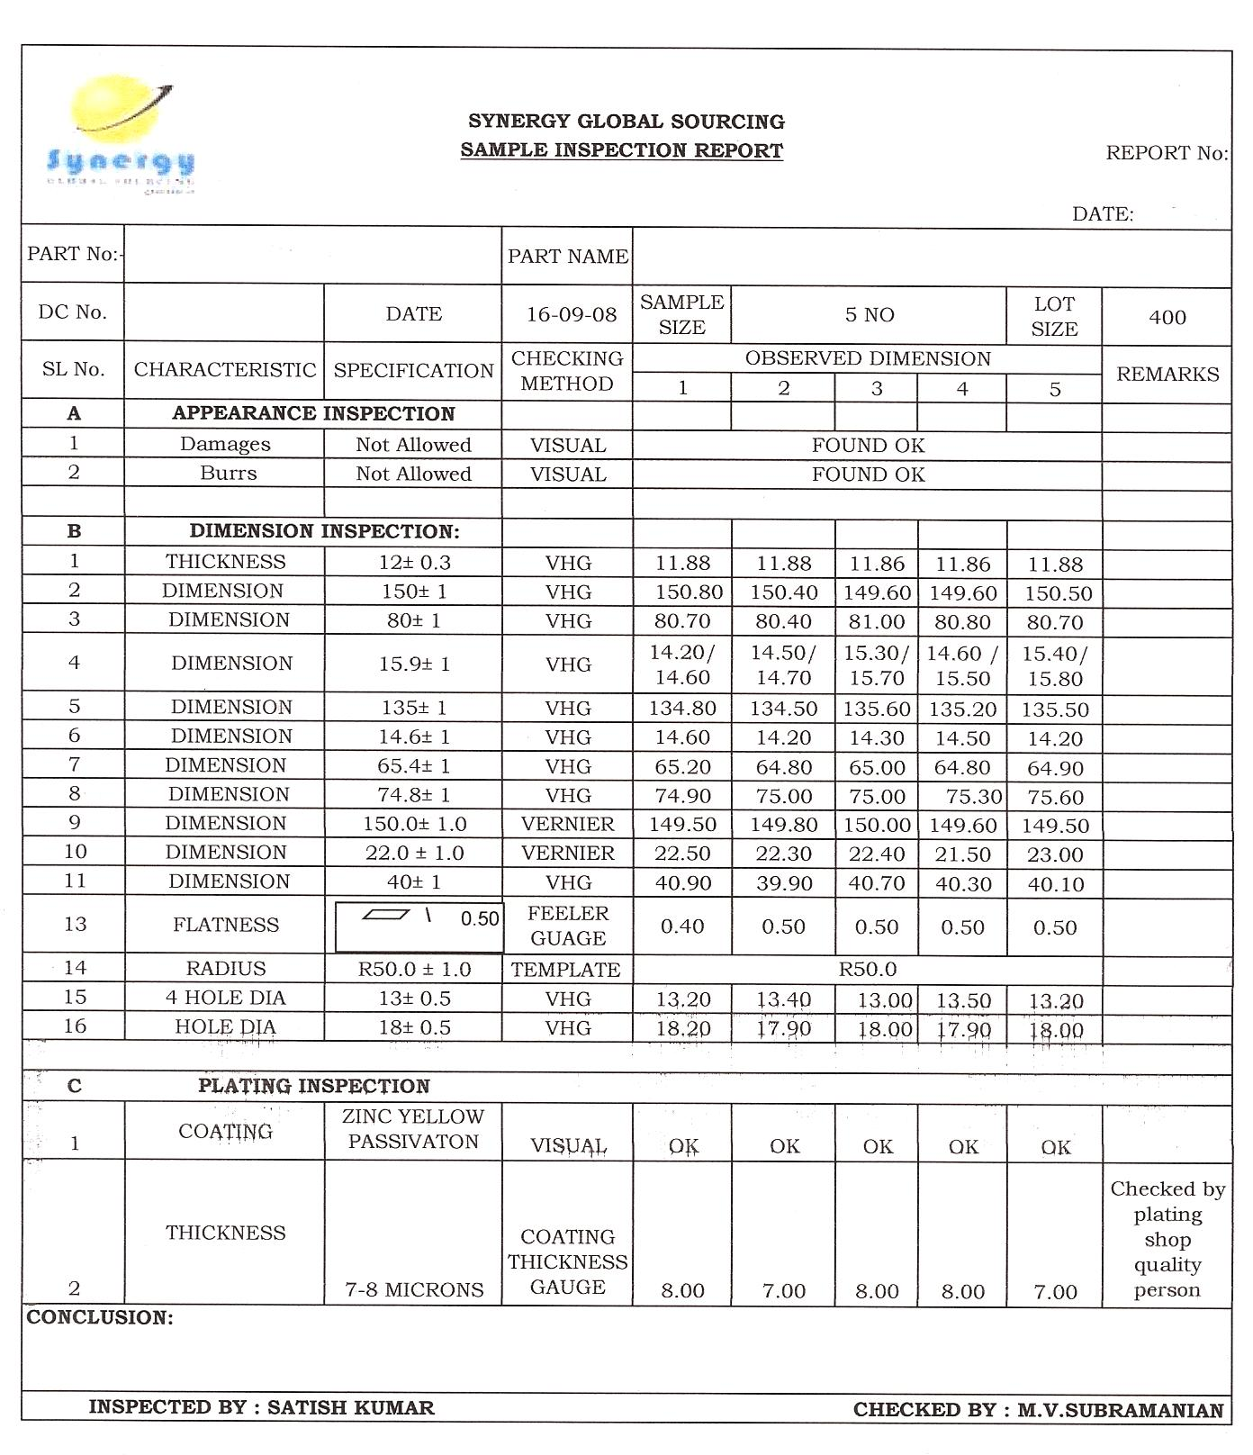

**http://www.synergyglobal.in/images/quality_inspection_docs/synergy_inspection_report.jpg**

**Appendix B**

**Report**

**Work Sheets**

**FABRICATION COST**



**PART INSPECTION REPORT**



**Appendix C**

**Report**

**Part drawings**

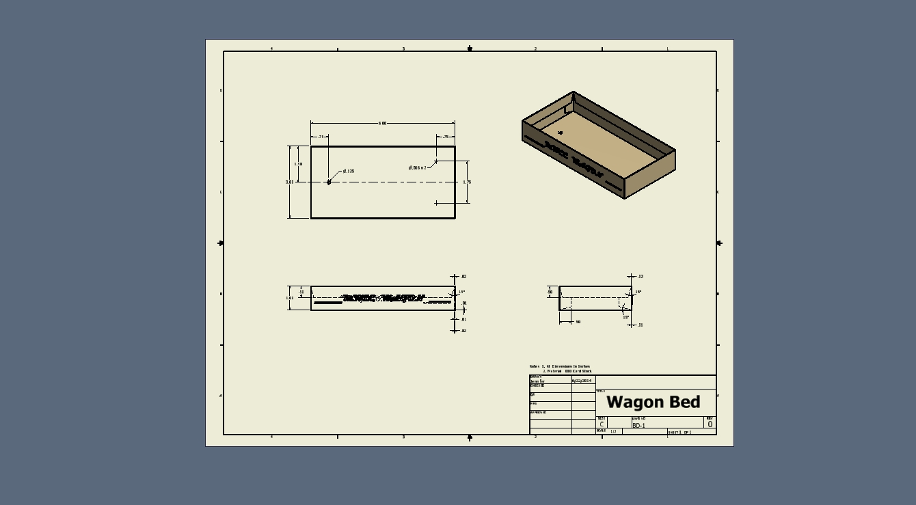

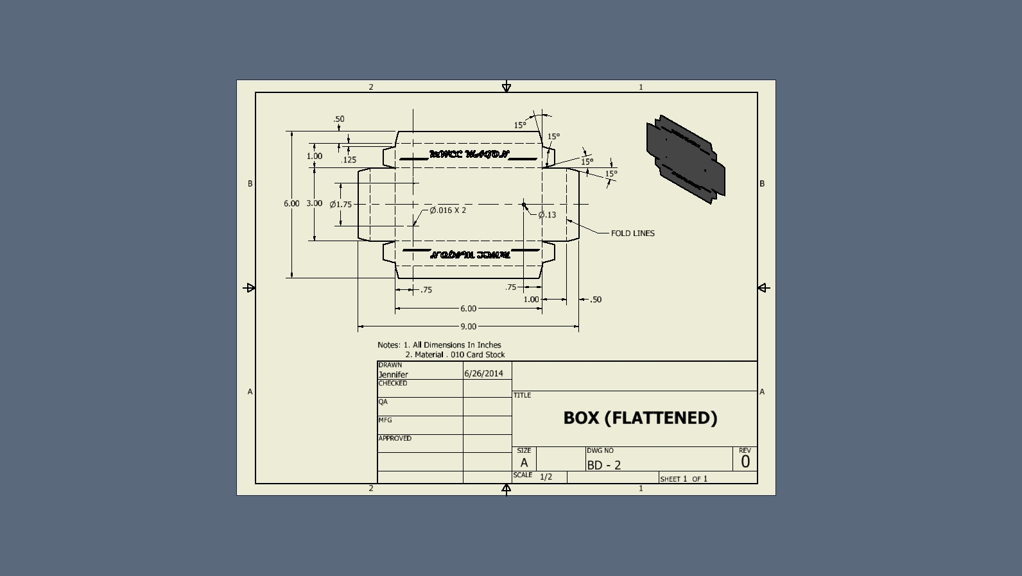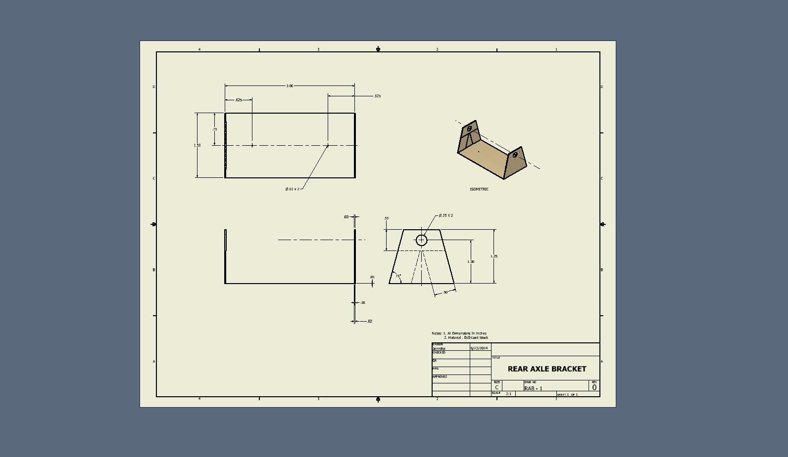

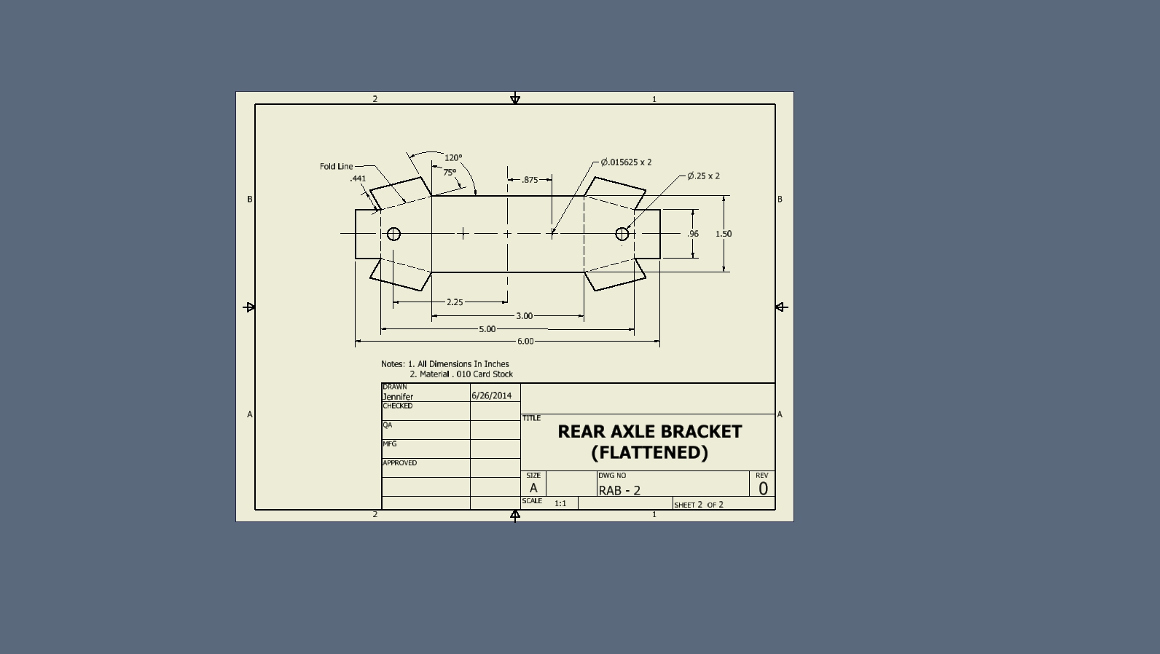

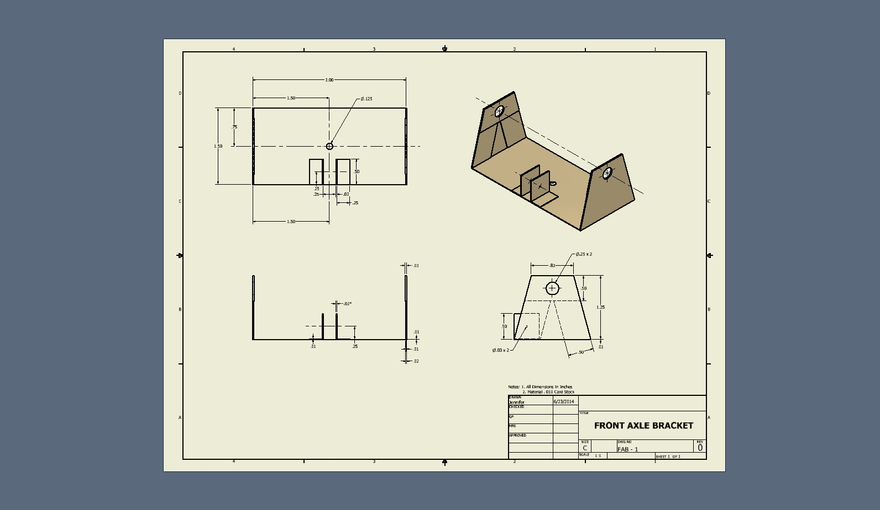

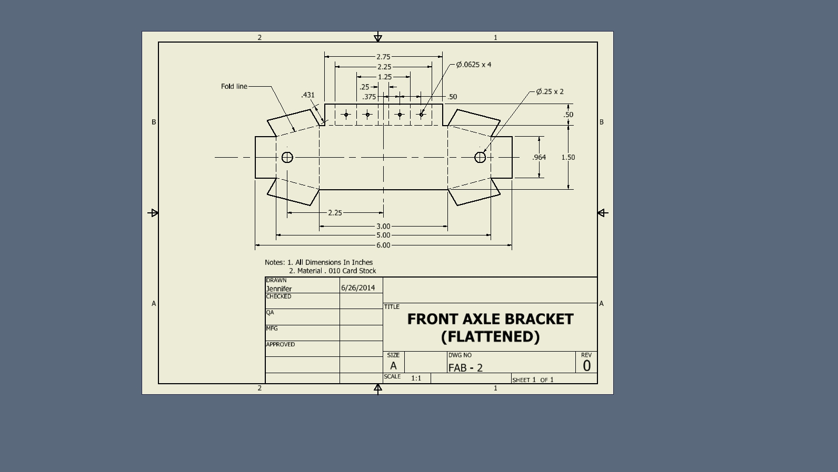

**a**