262 3D Printing: 1.2 Quiz
10 Points

This quiz is meant to be a quick brain exercise. Students may choose to draw 6 sided polygon a number of ways. The purpose is to get students to think about how to best draw and dimension a 6 sided nut. Use Inventor or Solidworks to create a 6 sided nut with 8mm sides and a 8mm hole. Once drawn, extrude the sketch 5mm. No need to thread the nut, but extra points could be possible.
- Use the sketch polygon tool and select a 6 sided polygon. (fastest)
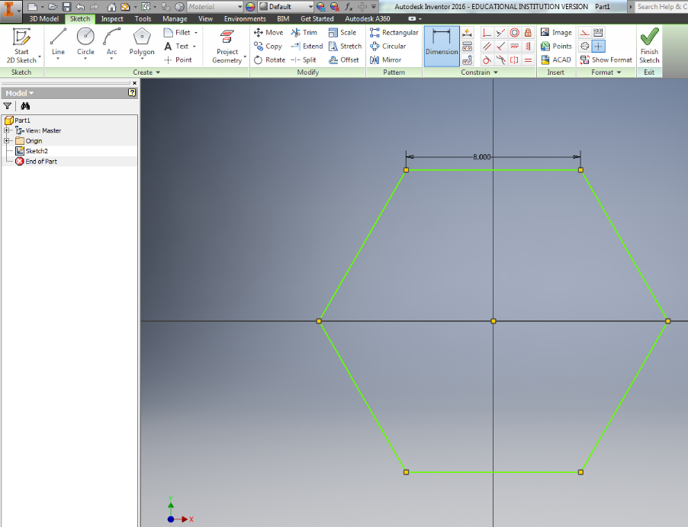

- Create parallel lines 8mm apart, rotate both lines 60 degrees, twice. Then trim.
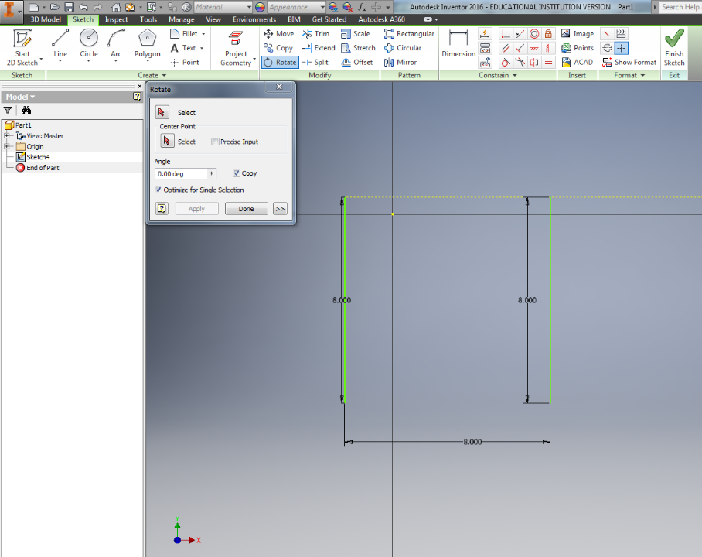

- Draw line 8mm long, draw next line, dimension angles and distance as you go (slowest)
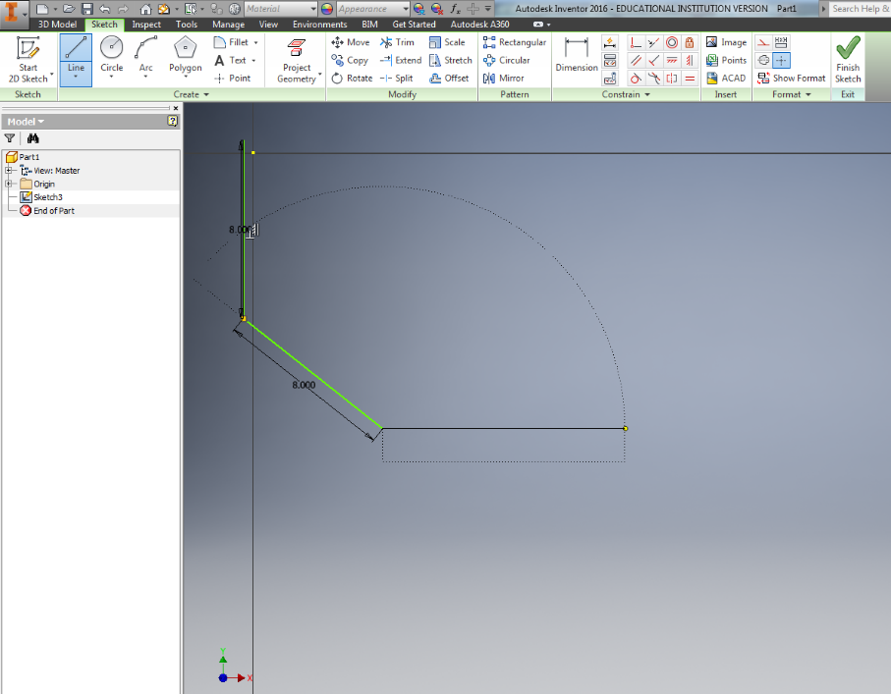

- Final Nut with correct Dimensions Below:
